

UniSA STEM

The University of South Australia

November 2020

INFS 1026 - Systems Requirements and User Experience

Assignment 2: User Experience Design for a Paramedical Emergency Response System

Quang Huy Tran

traqy014@mymail.unisa.edu.au

110 305 288

Tomas William Turner

Turtw003@mymail.unisa.edu.au

110 267 299

Douglas Hudson Walker

Huddy007@mymail.unisa.edu.au

110 322 362

## Team Contribution Declaration

Team No/Name: **51997-A2-01**

The following is a declaration of your individual contributions towards this group assessment. If any contribution does not meet the assessment requirements, the course coordinator may adjust individual marks up or down, depending on the level of contribution made.

Our team contributed equally to each section of the assignment. We worked cooperatively on each section from 1 - 10 and returned to it individually as more information was revealed about the previous sections.

## Version History

|  |  |  |
| --- | --- | --- |
| **Version** | **Date** | **Notes** |
| 0.1 | 03.11.20 | Initial Document Setup |
| 0.2 | 06.11.20 | Part 1: Stakeholders, Assignment 1 material transposed |
| 0.3 | 07.11.20 | Part 1: Stakeholders revised, refactored for assignment 2 |
| 0.4 | 10.11.20 | Part 2 & 3: Interview outline and transcript outlined |
| 0.5 | 11.11.20 | Part 4 & 5: Personas Outlined, User Stories Transposed (A1) |
| 1.0 | 12.11.20 | Document V1: assignment 1 refactored & outlines complete |
| 1.1 | 17.11.20 | Part 2 & 3: Questions revised; Dispatch transcript complete |
| 1.2 | 18.11.20 | Part 3: Paramedic transcript completed. |
| 1.3 | 20.11.20 | Part 4: User Stories from transcript added, INVEST, refactor |
| 1.4 | 21.11.20 | Part 5 & 6: Personas & matrix, amended stories via matrix |
| 1.5 | 22.11.20 | Part 7 & 8: Storyboards completed, Card Sorting, IA started |
| 1.6 | 23.11.20 | Part 8 & 9: IA & Look and feel complete, Priority list |
| 1.7 | 24.11.20 | Part 10: Prototype |
| 2.0 | 24.11.20 | All tasks complete, proofread, refactor. |

Table of Contents

Team Contribution Declaration 2

Version History 2

Task 1 – Stakeholders 4

User Stakeholders 4

Non-User Stakeholders 6

Task 2 – Interview Plan 8

Interview Plan 1 - Ambulance Driver 8

Interview Plan 2 - Dispatcher 11

Task 3 – Project and System Stakeholder Interview Transcript 14

Transcript Interview 1: Ambulance Driver 15

Transcript Interview 2: Dispatcher 20

Task 4 –User Stories Relevant to the user experience 25

Dispatcher 25

Ambulance Driver 27

Task 5 – Personas 28

Persona Breakdown 28

P01: David Deutsch 28

P02: Sheryl Clark 29

P03: Johnny Fisher 30

P04: Simone Weil 31

Task 6 – Matrix of User Stories to Persona’s 31

User Story, Persona Matrix 31

Updated User Stories 35

Task 7 – Storyboards 38

Common to Both Systems (Dispatch & Response) 38

Dispatch System 40

Response System 42

Task 8 – Information Architecture/Look and Feel 45

Information Architecture 45

Look & Feel 48

Task 9 – Priority List of User Stories (AKA Backlog) 48

Dispatch System 49

Response System 51

Task 10 – Prototype 53

Dispatch: 53

Ambulance Driver: 61

Appendix 1 – Assumptions 64

Appendix 2 - Task Analysis 64

Appendix 3 - Card Sorting – Information Architecture 68

Appendix 4 – References 71

# Task 1 – Stakeholders

## User Stakeholders

### Frist Degree Stakeholders

1. **Ambulance Driver / Paramedic**

Ambulance Drivers are one of the primary users of the system. They will use the system’s *Mobile Data Terminals* to help perform their responsibilities as Ambulance Drivers. It is important that the Ambulance Drivers are consulted for input into the design.

Ambulance Drivers will want to receive case information on the MDTs (Mobile Data Terminals) so they can perform their duties. They will need to communicate with Dispatchers and Hospitals, and this can be achieved via the system. Ambulance Drivers will want the system to support their ability to perform their responsibilities. This could include the suggesting the fastest routes to a case or hospital or suggesting relevant procedures or polices for their case.

Ambulance Drivers will only be using the response subsystem of the Paramedical Emergency Management System (PEMS). This does not mean that other systems, like the dispatch system, cannot be affected by their requirements. Ambulance Drivers deliver the product to the consumer (patients). The patients will see them as the interface to the PEMS. Therefore, their input should have a great impact on the entire system’s design.

1. **Dispatchers**

Dispatchers are primary users of the system. They will use the dispatch subsystem to assign categorised cases to *ambulance crews*. It is important that the Dispatchers are consulted for input into the system’s design.

Dispatchers will need access to categorised (triaged) cases. The case information they receive needs to be accurate so they can perform their responsibilities effectively. Dispatchers will want to assign cases to ambulance crews, quickly determine ambulance location in relation to case location, view ambulance crew status and availability, and send case callouts to all ambulance crews when none are available. Additionally, Dispatchers will want the new dispatch system to increase the efficiency and effectiveness of their job performance, so that patients secure the best possible outcomes. Automated tools which suggest the closest ambulance crews to a case, help to prevent the creation of duplicate cases, and allow dispatchers to communicate case information quickly will be desired.

Dispatchers will exclusively use the dispatch subsystem, however their input may affect the designs of other subsystems, as communication must occur between the systems.

### Second Degree Stakeholder

1. **Team Leaders**

Team Leaders perform many staff and shift management operations. They will use the system to assign paramedics to ambulance crews and crews to ambulances. Team leaders will also work to generate reports on ambulance crew usage. Team leaders will be older paramedics who are very experienced. They will want tools that keep them in contact with their teams.

NOTE: The employee management subsystem is considered separate from the dispatch and response subsystems and will not be explored further in this document.

1. **Patients**

The most important stakeholders according to SAAS [1] (SA Amublance Service, 2020). The system will directly affect patient welfare. The main concern of the system is patient safety and patients therefore have an active role in the key system decisions. Patients will come from all occupations and have all kinds of injuries. The system should be considering the diversity of patients and case types in its design.

1. **Hospital Staff**

Work directly with the outcomes of the system. A case’s patient will often be sent to a nearby hospital emergency department. The staff at the hospital are then responsible for that patient. Case information taken by the system will be vital to the patient’s welfare and the design should consider how this information is transferred to the staff. The hospital staff will also be interested in keeping dispatchers and ambulance drivers up to date with hospital issues and bed availability. Staff will not want additional patients if their emergency department is already full.

1. **Freedom of Information Requestors**

The system will produce output on all key events in the system. The information is then accessible to the public via Freedom of Information requests [2] (SA Amulance Service, 2020). The Citizens requesting this information are using the results of the system and the formatting and access of this information should be considered in the design.

NOTE: FOI requests are not considered part of the dispatch or response system and will not be explored further in this document.

### Third Degree Stakeholder

1. **Support Staff**

Support staff are responsible for providing troubleshooting and self-repair advise to the primary users of the system. They will need access to system documentation and training to perform their roles. The system should consider the communication channels required for primary users to contact support staff.

1. **Maintenance Engineers**

The engineers and developers responsible for maintaining the system providing hardware repairs, software hot fixes and updates. Maintenance Engineers will need to be trained and experienced to perform their jobs. It will be beneficial if the maintenance staff were involved in the development of the systems, so they have the deep knowledge required to perform their responsibilities. The system should consider how maintenance engineers are to access the system once is has been launched.

1. **Database Administrators**

Database Administrators are responsible for maintaining and updating the system databases and servers. Administrators will have a deep knowledge of the system’s back end services and data. Given that a large database already exists for the current system the database administrator may not be a member of the new systems development team.

1. **Network Engineers**

Network Engineers are responsible for the installation and maintenance of the systems wide area network. They will need access to building and equipment required to perform their responsibilities. The Network Engineers will require direct access to the system to perform troubleshooting and installation tests.

1. **Software Engineers and Developers**

Software engineers and Developers are responsible for the design and development of the system. They will need direct access to the system before during and after its deployment to the users. The engineers will influence the design of the system as they are responsible for implementing it.

## Non-User Stakeholders

1. **South Australian Ambulance Service (SAAS)**

The South Australian Ambulance Service is the primary client of the project. They report directly to SA Health [3] (SA Ambulance Service, 2020). They will provide most project resources and will have control of final decisions. SAAS will want the system to improve the current performance its staff. SAAS should be consulted on all high-level, key decisions in the design. They are not likely to be interested in the low-level details.

1. **SA Health - Minister for Health and Wellbeing (SA Health)**

SA Health is the brand name for the health services responsible to the Minister for Health and Wellbeing [4] (SA Health, 2020). They are responsible for the general health strategy within the state of South Australia. The SAAS report directly to SA Health. Like SAAS, SA Health will have a say in key decisions. They will want the system to be improve the performance of the SAAS. Their public popularity will be affected by its success or failure.

1. **SA Health - Local Hospitals**

Ambulance services will transport patients to hospitals in the Adelaide metropolitan area. Some key aspects of the system require communication with hospital staff (incoming patient alerts) and key availability data (beds available, machine issues). All key data points for Emergency Departments in the Adelaide metropolitan are collected by SA Health [5] (SA Health, 2020).

The system will need access to these data points and communication with hospitals in Adelaide’s Metropolitan and the design should consider how this data is to be handled. Local Hospitals will want the system to improve the communication between SAAS and their hospital staff, they will want the performance of patient hand-offs at emergency departments to be improved.

1. **Local Councils**

The system will be used across the South Australian metropolitan area including Central Adelaide and the Northern, Southern and Hills Regions. Local councils in these areas will need to be consulted on areas of the system affecting public amenities, including hospitals and road safety. The local councils will want the system to have a positive effect on their constituents.

1. **South Australian Metropolitan Fire Service (SAMFS)**

Emergencies are often the scene of multiple emergency services. Direct communication between these services helps deliver the speed and efficiency required by these situations. The SAMFS will be important partners in the systems development and can help provide professional expertise in key areas [6] (SAMFS, 2020). The SAMFS will want the system to improve communication with SAAS, streamlining the collaboration of these two services on individual cases and as a state-wide service.

1. **South Australian Police (SAPOL)**

Emergencies are often the scene of multiple emergency services. Direct communication between these services helps deliver the speed and efficiency required by these situations. SAPOL (South Australian Police) will be important partners in the systems development and can help provide professional expertise in key areas [7] (SAPOL, 2020). The SAPOL will want the system to improve communication with SAPOL, streamlining the collaboration of these two services on individual cases and as a state-wide service.

1. **Mader International Pty. Ltd. (Mader)**

Responsible for the installation of the MDT (Mobile Data Terminal) systems into SAAS ambulance vehicles [8] (Mader International Pty. Ltd., 2020). The system must fit the physical requirements required for these vehicles. Mader International will provide the physical limits for successful system installation. They are likely to have an effect on the system as the system will be limited by the equipment that is installed in the vehicles.

1. **SA Ambulance Employees Association (AEASA)**

The AEASA are the most prominent workers union for South Australian ambulance workers [9] (AEASA, 2020). The AEASA can provide expert advice for working conditions and considerations for paramedics. They will want the system to have appositive impact on SAAS employee’s health and well-being. They will affect the system’s design and call for the inclusion of usability and ergonomic features for users.

1. **Consumer and Community Advisory Committee (CACAC)**

The CACAC is responsible for providing SAAS with advice from the Ambulance Service consumer perspective. CACAC can provide great insights into the requirements for the system as a service to the end consumers [10] (SA Ambulance Service, 2020). The CACAC will want the system to return the best results for patients. They will affect the design of areas of the system which are public facing.

1. **Paramedical Professionals**

Professionals providing expert advice on paramedical industry standards and practices. Can provide important insights into type of language being used in the system. The stakeholder is likely to have used similar systems in the past and can provide insights on their design. They will affect the system design where medical accuracy is required.

1. **Paramedicine Board of Australia (Ahpra)**

Becoming an Australian paramedic requires a Bachelor of Science (Paramedical Science) and registration with Ahpra. Ahpra and its standards can provide insights to the type of education and training that paramedics will receive and thus the type of information that can be used and understood by paramedics on the job [11] (Paramedicine Board of Australia, 2020). They will want the system to be easy to learn and teach to training paramedics. They will want the system to provide documentation for teaching purposes.

1. **User Interface Designers**

The user interface will need to consider the working environment (long hours, stressful) and safety requirements. The user interface designers can provide expert knowledge on how to design for these constraints and the design of the system’s user interface.

1. **Software Designers and Developers**

Software teams and developers will be concerned with the processes used to develop the system. They will provide insights on the best practices for developing systems of this nature. Developers will deeply affect the end results of the system as they will be responsible for its implementation.

1. **Project Managers**

The project managers of systems development and design teams working on the project. Will provide insights into the strengths and weaknesses of certain development processes. They will attend in stakeholder meetings to inform other stakeholders about production progress.

# Task 2 – Interview Plan

## Interview Plan 1 - Ambulance Driver

|  |  |
| --- | --- |
| **Interviewee:**  Ambulance Driver | I**nterviewer:** |
| **Location/Medium:**  Office/ Hospital | **Appointment Date:**  **Start time:**  **End time:** |
| Objectives:   * Understand the current working process of Ambulance Driver. * Understand the information requirements for the system. * Understand what type of feature that Ambulance Driver would want in the system. | Reminders: |
| **Agenda:**  Introduction  Background on Project  Overview of Interview  Topics to be covered  Permission to Record  Question 1  Question 2  Question 3  Question 4  Question 5  Question 6  Question 7  Question 8  Question 9  Question 10  Question 11  Question 12  Question 13  Questions from Interviewee  Summary of Major Points  Closing Statement | **Approximate Time:**  1 minute  2 minutes  1 minute  2 minutes  1 minutes  2 minutes  2 minutes  1 minutes  3 minutes  2 minutes  2 minutes  1 minutes  2 minutes  1 minutes  1 minute  3 minutes  3 minutes  3 minutes  1 minute  ***~36 minutes*** |
| General Observations: | |
| Unresolved Issues, Topics Not Covered: | |
| **Questions** | **Notes** |
| Opening Question:  What gives you the most satisfaction when performing your job? | Answer:  Observations: |
| Question 2:  How does one become a Paramedic? What are the requirements to become accredited? How did you become a paramedic? | Answer:  Observations: |
| Question 3:  Describe the processes involved in receiving and managing a case using the current case management system. | Answer:  Observations: |
| Question 4:  What do you think works well with the current system? | Answer:  Observations: |
| Question 5:  What are biggest issues you face now with the current system? | Answer:  Observations: |
| Question 6:  What wastes the most of your time with the current case management system? | Answer:  Observations: |
| Question 7:  What are the most important pieces of information required to receive, manage, and resolve a case? | Answer:  Observations: |
| Question 8:  Are there any steps in the current system that you repeat for every case?  i.e., typing in destination for every case or searching for a policy or procedure manually. | Answer:  Observations: |
| Question 9:  Describe the effect that stress has on performing your responsibilities as a Paramedic. | Answer:  Observations: |
| Question 10:  Relating to case management, what task would you consider to be the most safety critical in the current system? | Answer:  Observations: |
| Question 11:  Are any features you would like to see added to the system?  Follow up:  How would these features help you conduct your work more effectively? | Answer:  Observations: |
| Question 12:  How often do you personally handle a category 1 case? (choose 1)   * Once a week (5 shifts) * Every third shift * Once a shift * Other? (please specify) | Answer:  Observations: |
| Question 13:  What does it take to become a successful paramedic? | Answer:  Observations: |
| Questions from the Interviewee:  Is there anything you would like to ask us? Are there any suggestions or features you would like to see? | Answer:  Observations: |

## Interview Plan 2 - Dispatcher

|  |  |
| --- | --- |
| **Interviewee:**  Dispatcher | **Interviewer:** |
| **Location/Medium:**  Office/ Hospital | **Appointment Date:**  **Start time:**  **End time:** |
| Objectives:   * Understand the current working process of Dispatcher. * Understand the information requirements for the system. * Understand what type of feature that Dispatcher would want in the system. | Reminders: |
| **Agenda:**  Introduction  Background on Project  Overview of Interview  Topics to be covered  Permission to Record  Question 1  Question 2  Question 3  Question 4  Question 5  Question 6  Question 7  Question 8  Question 9  Question 10  Question 11  Question 12  Question 13  Question 14  Question 15  Question 16  Questions from Interviewee  Summary of Major Points  Closing | **Approximate Time:**  1 minute  2 minutes  1 minute  3 minutes  2 minutes  1 minutes  2 minutes  1 minutes  1 minutes  2 minutes  2 minutes  1 minutes  2 minutes  1 minute  2 minutes  1 minutes  1 minutes  2 minutes  3 minutes  3 minutes  3 minutes  1 minute  ***~38 minutes*** |
| General Observations: | |
| Unresolved Issues, Topics Not Covered: | |
| **Questions** | **Notes** |
| Opening Question:  What gives you the most satisfaction when performing your roles as a Dispatcher? | Answer:  Observations: |
| Question 2:  Can you describe a typical working process of dispatching a case to an Ambulance Crew? | Answer:  Observations: |
| Question 3:  How did you become a dispatcher? | Answer:  Observations: |
| Question 4:  What are biggest issues you face now with the current system? | Answer:  Observations: |
| Question 5:  What is the average daily number of cases that you receive? | Answer:  Observations: |
| Question 6:  What features do you think might enhance your working speed? | Answer:  Observations: |
| Question 7:  What computer platform do you use at your dispatching headquarters? i.e., Windows 10, Apple Mac OSX | Answer:  Observations: |
| Question 8:  How long is a typical shift for a Dispatcher? | Answer:  Observations: |
| Question 9:  What are the most important pieces of information required to dispatch a case? | Answer:  Observations: |
| Question 10:  How do you organize the suitable Ambulance Crew for each case? | Answer:  Observations: |
| Question 11:  How do you deal with the lack of Ambulance Crew in emergency case? | Answer:  Observations: |
| Question 12:  How do you deal with high loads, peak hours, or state emergencies? Is there a procedure to follow in these circumstances? | Answer:  Observations: |
| Question 13:  Have you ever lost any records of information? If yes, how often? | Answer:  Observations: |
| Question 14:  How do you keep track of all the categorised cases and assigned cases? | Answer:  Observations: |
| Question 15:  What has wasted the most of your time with the current dispatching system? | Answer:  Observations: |
| Question 16:  Are there any steps in the current system that must be repeated every time but need not be?  *For example: Inputting dispatcher ID and passcode more than once.* | Answer:  Observations: |
| Questions from the Interviewee:  Is there anything you would like to ask us? Are there any suggestions or features you would like to see? | Answer:  Observations: |

# Task 3 – Project and System Stakeholder Interview Transcript

All the interviews started with an introduction with the interviewee. The interviewer then provided some background for the project, and an overview of the interview including the topics to be covered. The interviewer then asks permission to record and that is where our transcripts begin.

NOTE: In the next section we create user stories. We used the information from the transcripts to build on our user stories. A table is shown after each question and answer with the related user stories and notes from the interview.

## Transcript Interview 1: Ambulance Driver

### Ambulance Driver - David Deutsch

**Interviewer:** Okay, ready?

**David:** Yep, ready to go.

#### Question 1

**Interviewer:**  Okay first question, what gives you the most satisfaction when performing your job? (Ambulance Driver)

**David:** Huh, Umm. Well, the job is very rewarding. I help people in their most dire moments, moments they will remember for the rest of their life. I have remained friends with many of my patients, which is something I cherish greatly. I wanted a career where I could help people and that is the bread and butter of this job.

**Interviewer:**  Yes, it seems like a very fulfilling job.

|  |  |
| --- | --- |
| **Answers Summary / Notes**   * Helping people * Remaining friends with patients | **Related user stories**   * US39 |

#### Question 2

**Interviewer:**  This feeds into the next question nicely. How did you start that career? How does one become a paramedic? What are the requirements to become accredited?

**David:** “Right, so the first thing you need is a 3-4-year Paramedic’s bachelor’s degree. I finished my degree at Flinders University. A Bachelor of Paramedic Science…., As of 2018, You’ll also need to register with Ahpra, which is the Paramedic Board of Australia. It can take a couple of months. But once your approved you are an accredited paramedic and can start your training. You need to renew your Ahpra registration each year.”

**Interviewer**: Right, so how does one start working? How did you get your first job for example?

**David:** Ah it was a while ago now, but if I remember correctly, I was able to secure my start with the SAAS through the university. Nowadays, you can apply yourself by contacting them directly. SAAS will put you through their training which is a couple of weeks, then if your fit enough, you get an assigned ambulance crew and an experienced partner and you do on the job training for about a year. It also depends if you are trying to be a paramedic or a PTO. PTO’s just need a cert IV.

**Interviewer**: What is a PTO?

**David:** Ah sorry, A PTO is a Patient Transport Officer, they can handle non-emergency patient transport.

**Interviewer**: Ah I see.

|  |  |
| --- | --- |
| **Answers Summary / Notes**   * Paramedic: 3-4-year Bachelors of Paramedicine * Paramedic: Register with Ahpra [11] (Paramedic Board of Australia) * PTO: Certificate IV in non-emergency patient transport * Complete training session with SAAS * On the job training up to a year | **Related user stories**   * US28 |

#### Question 3

**Interviewer**: Alright, next question. Please, describe the processes involved in receiving and managing a case using the current case management system.

**David:** Umm, so describe the process from the moment I receive a case?

**Interviewer:** Ah yeah, that’s right.

**David:** Right so, I would receive a case and the bell would go off to let me know and then… whoever is hands free at that moment will read out the case urgency code and the general location. We would accept the case if we can, signal we are on route, and then hands free will punch in the destination into the GPS. If the case is an emergency, we turn on lights and sirens. On the way we discuss the case details. What type of case we are dealing with, is it a heart attack, a road accident, etc. Based on that information we would prepare any equipment that is required.

**Interviewer:** How do you decide which equipment is required? Do you have any checklists for that kind of thing?

**David:** Yeah, we have procedure checklists for different case types. It is a hassle to use though because we have digital and paper copies. We usually use the paper copy because the digital one takes up the screen real estate, we use to see the case information. But the paper ones are kind of unwieldly too, so mostly we go by experience and then come back to the list when we need to.

**Interviewer:** Okay, that makes sense. So, once you arrive at the case location what is the process in terms of case management?

**David:** Ah, we signal on the system that we have arrived on site and then we handle the situation the way we have been trained. Depending on the case we may need to deliver the patient or patients to a nearby hospital. We would indicate this on the system. Once a patient is at the hospital or we have provided the services they require we signal the case has been resolved.

**Interviewer**: Sounds like you know what you’re doing.

|  |  |
| --- | --- |
| **Answers Summary / Notes**   * Regarding the current system’s process * Receive case notification and information * Read out case information and location * Accept case if possible, signal on route * Type in destination into GPS * If emergency, turn on lights and sirens * Discuss case details with partner * Prepare required equipment (using experience and procedure checklist) * Signal upon arrival * Indicate transporting patient to hospital if required * Indicate resolved case if hospital delivered or services rendered | **Related user stories**   * US31 * US32 * US33 * US40 * US41 * US45 * US32 * US33 * US34 |

#### Question 4

**Interviewer**: So, what do you think works well with the current case management system?

**David:** The system tells us simply the information we need to do our job. It is explicit and concise. It does not do anything fancy, but it tells us all the case details we need to get the job done right.

|  |  |
| --- | --- |
| **Answers Summary / Notes**  Regarding the current system   * Simple, Clear, Concise * Does not overload with information * Does the job | **Related user stories**   * US29 * US26 |

#### Question 5

**Interviewer**: Okay, inversely, what are biggest issues you face now with the current system?

**David:** It is hard to read. I have developed some eyesight issues and the text seems to be getting smaller and smaller. The black and white monochrome makes it difficult to parse the case information.

|  |  |
| --- | --- |
| **Answers Summary / Notes**  Regarding the current UI   * It is difficult to read (text size, no formatting) | **Related user stories**   * US30 |

#### Question 6

**Interviewer**: Alright this is a similar question, what wastes the most of your time with the current case management system?

**David:** Umm…,We seem to waste a fair amount of time transferring the location of the case into our GPS. It is time we could use for preparation. We need to do it for every case. Also, if we need to deliver a patient to hospital, we need to figure out the closest hospital and then radio ahead to see if they have space. Sometimes we need to double back if the hospital is full.

**Interviewer**: Auh, that sounds frustrating.

|  |  |
| --- | --- |
| **Answers Summary / Notes**   * Transferring the case location into GPS * Determining closest and best (bed availability) hospital | **Related user stories**   * US40 * US41 * US42 * US43 * US44 |

#### Question 7

**Interviewer**: What do you think are the most important information required to manage, and resolve a case?

**David:** Well, I’d say the most important bits are the location, so we know where we are going, the case urgency, so we know how fast to get there, and the case type, so we know what to prepare for the case. Having said that, all of the information is important, small notes about case location access or patient notes can really help us out. Even the trivial details can save lives.

**Interviewer**: Yes, that’s interesting. Does the current system store additional notes like that?

**David:** No actually, it depends on the dispatcher and the case type. If we need more information we will radio in and ask but sometimes the dispatchers will radio us and provide any details, they think are important.

|  |  |
| --- | --- |
| **Answers Summary / Notes**   * Case location (know where we are going) * Case urgency (know how fast to get there) * Case type (know what to prepare) | **Related user stories**   * US35 * US36 * US37 |

#### Question 8

**Interviewer**: Okay, are there any steps in the current system that you repeat for every case? You have already mentioned inputting the case location into your GPS, are there any other repeated tasks?

**David:** Well yes, there is also the checklists, in most cases we need to look up the checklist of policies and procedures related to the case. We can use the MDT but then we can’t see the case details and the system doesn’t provide any suggestions anyway, so you need to know what to look for.

|  |  |
| --- | --- |
| **Answers Summary / Notes**   * Transferring case location into GPS * Looking up policies and procedures (no suggested policies for case type) | **Related user stories**   * US40 * US41 * US45 * US46 * US47 |

#### Question 9

**Interviewer**: Describe the effect that stress has on performing your responsibilities as a Paramedic.

**David:** It is a good question, although the stress doesn’t get to me as much anymore. I think I have been a little de-sensitized to it. Most of the medics handle themselves well and thrive under the pressure. The greener ones can get overwhelmed sometimes; I was in the same boat when I started. It can be debilitating if you don’t keep it under control. You lose track of what you’re doing, and it can be difficult to work logically in those situations.

|  |  |
| --- | --- |
| **Answers Summary / Notes**   * More Experience means less of an effect * Paramedics tend to thrive under pressure * Newer trainees get overwhelmed * Difficult to work logically * Lose track of what you are doing | **Related user stories**   * US28 * US29 * US47 |

#### Question 10

**Interviewer**: Yes, that sounds difficult. Relating to case management, what task would you consider to be the most safety critical in the current system?

**David:** Ah well, managing stress is definitely in this category. But I think communication is very important. We use the radios frequently to keep in contact with our dispatcher and to relay case information as required…. It's important that the case information is accurate also. There have been times the case should have been considered category 1 but has been graded category 2. Which means we do not use the lights and sirens and that can be fatal.

|  |  |
| --- | --- |
| **Answers Summary / Notes**   * Managing stress * Communication with dispatcher * Accurate case information | **Related user stories**   * US38 * US27 |

#### Question 11

**Interviewer**: Are any features you would like to see added to the system?

**David:** I would like the system to be more practical. I want to be able to see case information at all times. If I search for a procedure, the case information disappears. The case info is the most important information. It would also be nice for the relevant procedures to show up based on the case type too. In fact, features like that, which streamline the processes for doing our job. That’s what you should focus on. And easier communication with the dispatcher. Usually, the dispatcher will need to radio in any changes to the case. It would be easier for any update to be shown on the system.

|  |  |
| --- | --- |
| **Answers Summary / Notes**   * Practicality (see case information at same time as policies and procedures) * Suggestions for policies based on case type * More features for automation like suggested policies * Increased communication with dispatcher | **Related user stories**   * US35 * US47 * US41 * US32 * US38 |

#### Question 12

**Interviewer**:

How often do you personally handle a category 1 case? (choose 1)

* Once a week (5 shifts)
* **Every third shift**
* Once a shift
* Other? (please specify)

**David:** Probably every third shift. It depends on the time of the year too. The holidays are always busier for that kind of thing and I have noticed there is always an uptick for heart attacks when the time changes for day light savings.

|  |  |
| --- | --- |
| **Answers Summary / Notes**   * Every third shift * It depends on the time of the year. | **Related user stories**   * None in the target subsystems |

#### Question 13

**Interviewer**: Okay last question, what does it take to become a successful paramedic?

**David:** Oh, ha-ha well I, ah. I think it takes someone to love the job first of all. The double shifts take it out of you, it is certainly not a walk in the park. You should probably be a people person too. You shake a lot of hands in this job and people are grateful. But yeah, a bit of grit, determination, perseverance, that kind of thing.

|  |  |
| --- | --- |
| **Answers Summary / Notes**   * Love of the job * Perseverance, determination, grit * Being a people person | **Related user stories**   * None in the target subsystems |

## Transcript Interview 2: Dispatcher

### Dispatcher – Johnny Fisher

**Interviewer:** Okay, are you ready for the first question?

**Johnny:** Sure, let’s do it.

#### Question 1

**Interviewer:** Okay, firstly what gives you the most satisfaction when performing your roles as a Dispatcher?

**Johnny:** Well, I am very honoured to have a job like this. My actions directly save lives and I feel grateful to be a part of such a noble endeavour. There is, however, a degree of separation between a dispatcher and the patient and I feel that ambulance crews get more recognition. Not that I need recognition it would just be nice to see more directly the results of my work. It brings me satisfaction seeing patients who make full recoveries.

|  |  |
| --- | --- |
| **Answers Summary / Notes**   * Honoured by the job * Get satisfaction from helping people in need * Would like to see the results of his work | **Related user stories**   * US20 |

#### Question 2

**Interviewer:** Nice, it seems that many people would really appreciate your job, but I think it would be stressful and strenuous work. Can you describe the typical process of dispatching a case to an Ambulance Crew?

**Johnny:** Thanks. Well first I receive a triaged case from a call taker. The case appears in a list with other unassigned cases. Each dispatcher shares the list of cases. I usually chose the highest priority case unless a lower priority case has been sitting for a while. I add the cases suburb to a list I keep on a post-it-note. Whenever I assign a case, I yell out the cases suburb and my name so that other dispatchers can add to their lists, that way we know if there is a duplicate case and which dispatcher is handling it. When we get a case with a matching suburb then we call the associated dispatcher to sort it out.

**Interviewer:**  Incredible, how do you know if a case has been resolved? By the end of the day all the suburbs in your headquarters could have been yelled out. And what if there are multiple cases in one suburb?

**Johnny:** I admit it is not the best solution. If we get a duplicate the receiving dispatcher verbally confirms with the related case’s dispatcher before assigning the new case. If a case is resolved, we call out the suburb our name and the word “complete” like a radio technician. Then all the dispatchers cross that off their lists. It’s difficult, it means that a single dispatcher needs to limit the number of cases they have in the same suburb.

**Interviewer:**  Okay jeez, you’ve written down the case’s suburb, what next?

**Johnny:** Oh yeahright, well first I’ll find the closest available crew using my knowledge of Adelaide or more often the map on my desk. I assign the case to that crew. Once I’ve done that, the ambulance crew receives all the case information. If the case is category 1, I will also look at the busy ambulances to see if there is a closer alternative. If its high priority and there are no ambulances available, I’ll send a call out to all the ambulances for the case. Once an ambulance crew accepts a case, its status changes to assigned. Its only then that I record and yell out the suburb. I will then continue to monitor the case while assigning other cases. More often than not the ambulance crew will radio us to get more information.

|  |  |
| --- | --- |
| **Answers Summary / Notes**  DispatchProcess in Order after receiving case:   * Received cases appear in a list with other assigned cases. * The list is shared amongst the dispatchers * Usually choses the highest priority case, unless there is a case that has been pending * Uses a hardcopy map of Adelaide. * Assigns the case to closest ambulance. * Waits for them to accept * Once accepted, adds the case suburb to a post-it-note list, yells out their name and the suburb for other dispatchers to record. * Dispatcher continues to monitor case whilst assigning other cases. * Will usually receive call from ambulance crew. * Once the case is resolved the dispatcher again yells out the case suburb, their name, and the word COMPLETE. | **Related user stories**   * US16 * US8 * US9 * US10 * US18 * US13 |

#### Question 3

**Interviewer:** This is really helpful, thank you. Next question. How did you become a dispatcher? What are the requirements to become accredited?

**Johnny:** Well, I finished my 3-year Paramedic Science bachelor’s degree at CQUniversity Australia, accomplish Certificate IV Ambulance Communications then started working as a paramedic for 5 years before receiving this Dispatcher role. In general, the basic requirements include First Aid qualification and Certificate III Ambulance Communications. Moreover, necessary characteristics of an accredited Ambulance Dispatcher are ability to stay calm under pressure, good communication, listening skills and some standard IT skills.

|  |  |
| --- | --- |
| **Answers Summary / Notes**   * Optional: 3-year paramedic science bachelor’s degree * Optional: experience as a paramedic * Optional Certificate IV in ambulance communications. * First aid Certification * Certificate III in ambulance communications * Characteristics: * Calm under pressure * Good communication and listening skills * Standard IT skills | **Related user stories**   * US3 |

#### Question 4

**Interviewer:** What are biggest issues you face now with the current system?

**Johnny:** Well, I think the biggest issue for me is the determining the closest ambulance crew for the case. Each ambulance appears in a list on the screen which a status and location. But I need to know where the suburb is located and all I have is a paper copy map. I usually just eyeball it. I know where most of the suburbs are in relation to each other by heart now, so I just send the ambulance in the closest suburb.

|  |  |
| --- | --- |
| **Answers Summary / Notes**   * Determining ambulance location in relation to case * Needs to rely on knowledge of Adelaide | **Related user stories**   * US9 * US10 |

#### Question 5

**Interviewer:** What is the average daily number of cases that you receive?

**Johnny:** Oeuf, that’s a hard one. Umm, it’s hard to say. It depends on what month it is. Some days are worse than others, if there is a major incident there is a lot of cases to manage. If you want a number probably around, ahhh, not sure maybe 40 or 50, could be more I’m not sure. You should be able find that information in the SAAS annual report.

**Interviewer:** Thanks for the tip we will look into it.

|  |  |
| --- | --- |
| **Answers Summary / Notes**   * Around 40-50 cases a day * Did not seem certain. * According to the SAAS 2018/19 annual report [12] (SAAS Ministerials, 2019), the SAAS received on average 869 call per day state-wide. There are 4 headquarters (218 cases per headquarters) assuming each headquarter has 8 dispatchers, that’s ~28 cases per day. | **Related user stories**   * US1 * US19 |

#### Question 6

**Interviewer:** Can you think of any features which wouldenhance your work efficiency?

**Johnny:**  I think the automation of tracking and Ambulance Crew/route suggestion would be the most efficient feature to boost up my working process. The current system does not have a map that update the real time locations of all Ambulance Crews both assigned and available. This feature would allow me to track and find the suitable Crews without manually asking for it every time I need. The expected system should have ability to suggest the closest Ambulance Crews to the case’s site or suggest an alternative route to a higher priority call in case there is no available Ambulance Crew. The arrangement of suitable Ambulance Crews to different categories of cases are very complex if we receive a variety of calls so these built-in functions would enhance the speed and accuracy of dispatching process.

|  |  |
| --- | --- |
| **Answers Summary / Notes**   * Update real-time Ambulance Crew locations on map. * Automatically suggest the closest Ambulance Crew and alternative route for higher priority cases. | **Related user stories**   * US9 * US7 * US10 * US14 |

#### Question 7

**Interviewer:** What computer platform do you use at your dispatching headquarters? i.e., Windows 10, Apple MacOS

**Johnny:** The system at dispatching headquarters is operating on Windows 10 so I am quite familiar with this platform. However, the existing software is too old and responding very slow with minimal automation functionality.

|  |  |
| --- | --- |
| **Answers Summary / Notes**   * Windows 10 | **Related user stories**   * None |

#### Question 8

**Interviewer:** How long is a typical shift for a Dispatcher?

**Johnny:** About 8 hours, we need to resolve all our active cases before signing off. Usually there are not enough dispatchers on call, so we need to do a second shift 8 hours later. It can be quite rough if you don’t get some sleep in.

|  |  |
| --- | --- |
| **Answers Summary / Notes**   * Need to resolve all cases before ending shift * Double shifts (two shifts in one 24-hour period) are common * Complaints about lack of sleep | **Related user stories**   * US1 * US3 * US4 * US17 |

#### Question 9

**Interviewer:** What are the most important pieces of information required to dispatch a case?

**Johnny:** Case urgency and location is probably the most important I need to know where the case is so I can assign the right crew. If the case is urgent, I need to work quickly to get it resolved.

|  |  |
| --- | --- |
| **Answers Summary / Notes**   * Case urgency * Case location | **Related user stories**   * US2 |

#### Question 10

**Interviewer:** How do you organize the suitable Ambulance Crew for each case?

**Johnny:** Well,after receiving the categorised case, first I read the case category to understand its urgency. With current system, I must go through the list of available Ambulance Crews, check the location of each one in relation to the case and then decide which available ambulance is closest.

|  |  |
| --- | --- |
| **Answers Summary / Notes**   * After receiving a categorised case: * Carefully read details to understand priority * Go through list of available ambulance crews * Check location of each one, calculate the distance * Send the closest ambulance | **Related user stories**   * US16 * US2 * US7 * US10 |

#### Question 11

**Interviewer:** How do you deal with the lack of Ambulance Crew in emergency case?

**Johnny:** If the case is an emergency (category 1) then I will post a call out to all the ambulance crews. The call out contains the case location and crew need to decide if they can drop their current case to take on the high priority one. The crew would call me over the radio to confirm they are taking on the case. I then override their current case and assign the high priority on over. The other case goes back on the unassigned list.

|  |  |
| --- | --- |
| **Answers Summary / Notes**   * Sends a call out to all ambulance crews * Ambulance crew will call back if they can take the case * Override current case with new one * Old case goes back into unassigned case list | **Related user stories**   * US11 * US13 * US14 * US15 |

#### Question 12

**Interviewer:** How do you deal with high loads, peak hours, or state emergencies? Is there a procedure to follow in these circumstances?

**Johnny:** Usually a high load is predictable. Public holidays, football games, and the summer holidays are always busier. We roster on more staff for those events and that usually covers it. It is a little different is an unforeseen emergency. Once the case load gets high enough, we would call in more dispatchers. But even then, we can get overwhelmed and there is no real procedure to help. We just take it case by case and do our jobs the best we can. Those are the days the adrenaline really starts pumping and you need to be on your game.

|  |  |
| --- | --- |
| **Answers Summary / Notes**   * High loads are usually predictable * More dispatchers are rostered on for these occasions * Football matches, public holidays and summer breaks are busier * No procedure when dispatchers overwhelmed | **Related user stories**   * US19 * US1 |

#### Question 13

**Interviewer:** Have you ever lost any records of information? If yes, how often?

**Johnny:** Umm, not personally no. There was a small amount of data lost a couple years ago. That was only one days’ worth of cases, I think. It does not really happen that much.

**Interviewer:** Any idea what went wrong?

**Johnny:** ah not really, sorry. It was a while ago; my guess is that it was a connection issue because it was only one days’ worth.

|  |  |
| --- | --- |
| **Answers Summary / Notes**   * Not personally * Knows of an occasion when there was data loss but says that its rare. * Should ask the current systems database administrator about the backup procedures. | **Related user stories**   * None in target sub systems |

#### Question 14

**Interviewer:** How do you keep track of all the categorised cases and assigned cases?

**Johnny:** Well,each case is shown in a filtered list, you have a list for the unassigned and resolved cases. The most urgent unassigned cases are shown at the top. There is another list for your active cases. The active cases in your list can be filtered by location, status (on route, on site, transporting), or type.

|  |  |
| --- | --- |
| **Answers Summary / Notes**   * Unassigned and resolved cases are shown in a filtered list (by urgency). * Active cases are shown in another list, also filtered. * Dispatchers can sort cases by location, urgency, and status. | **Related user stories**   * US8 * US2 * US19 |

#### Question 15

**Interviewer:** You have mentioned that determining the closest and best ambulance crew of ra case is difficult. Other than this.What has wasted the most of your time with the current dispatching system?

**Johnny:** Ah well, I think the most wasteful thing is having to write all those posts it notes for the suburbs. I need to be on alert all the time for dispatchers to yell out their cases, sometimes they forget, sometimes I do not hear them. If you are creating a duplicate case, it wastes your time and uses up more ambulance resources that it needs to.

|  |  |
| --- | --- |
| **Answers Summary / Notes**   * Calling out the suburb name constantly leading to errors and wasted ambulance resources * Duplicate cases are created by calling out * Everything is written on post it notes. | **Related user stories**   * US18 * US2 |

#### Question 16

**Interviewer:** Are there any steps in the current system that must be repeated every time but need not be? *For example: Inputting dispatcher ID and passcode more than once.*

**Johnny:** Ah well, I only need to sign in once at the start of my shift but, yes there are some things I need to do repeatedly. The suburb announcement is one of those. I’m constantly writing the addresses down to remember them, and I regularly need to write notes. When something changes in the case, like a new caller provided important information or a duplicate case has been found. I need to call the ambulance crew directly to let them know because I cannot amend the case once it has been assigned.

|  |  |
| --- | --- |
| **Answers Summary / Notes**   * Only needs to sign in once. * Repeats case suburb announcement * Writes a lot of case notes on paper * Writes down the address of the case * Once a case is assigned it cannot be amended | **Related user stories**   * US2 * US18 * US23 * US24 |

# Task 4 –User Stories Relevant to the user experience

The following user stories were created using our knowledge of the system, the provided scenario, and the interview transcripts found in the above section (task 3). However, they are not the final version of our user stories. Once the stories were put in a matrix it was clear some were very similar across systems (dispatch, response). The final version of our user stories can be found in here, in part 6.

## Dispatcher

1. As a Dispatcher, I want to navigate the system UI with the least amount of input possible so that I can assign the case to an Ambulance crew as quickly as possible.
2. As a Dispatcher, I want the case urgency, type, and location to be visible at all times, so that I do not need to write notes to remember them.
3. As a Dispatcher, I want to have a simple and clear user interface so that I can work with it easily under stress or with lack of sleep.
4. As a Dispatcher, I want the interface to use darker colours and lighting, so that my sleep is not affected when I finish my shift.
5. As an experienced Dispatcher, I want the interface to have optional shortcuts so that I can quickly complete regular tasks.
6. As a Dispatcher with poor eyesight, I want the interface to have a readable text size, colour scheme and formatting so that I can easily read case details and find information.
7. As a Dispatcher, I want to be able to view the location of all Ambulance Crews so that I can consider their closeness to the cases.
8. As a Dispatcher, I want to be able to see which Ambulance Crews are available so that I can assign new cases to them.
9. As a Dispatcher I want the interface to include a map of Adelaide detailing all ambulance crew locations, so that I can visually access their distance to a case.
10. As a Dispatcher, I want the system to automatically suggest the closest Ambulance Crew to a case so that I can assign the cases to suitable crews faster.
11. As a Dispatcher, I want to be able to send out a callout to all Ambulance crews for a category 1 or 2 case so that I can reduce the amount of time it takes to find an available Ambulance Crew.
12. As a Dispatcher, I want case information to be sent to ambulance crews when they are assigned, so that I do not need to relay the information by radio.
13. As a Dispatcher, I want to be able to contact an Ambulance Crew so that I can communicate case information and ask them of their availability in the case that there is no other ambulance crew available.
14. As a Dispatcher, I want the system to automatically suggest a suitable busy Ambulance Crew for high priority cases, in the case that there are no closer alternatives, so that I can prioritise urgent cases.
15. As a Dispatcher I want to be able to override an ambulance crew’s assigned case with a new one, so that more urgent cases can be resolved first.
16. As a Dispatcher, I want the interface to alert me when new cases become available, so that I can manage my case load and assign cases as they become available.
17. As a Dispatcher, I want to be able to hand my current case off to another dispatcher so that any issues (e.g., machine crashes, shift completed) will not impede the resolution of the case.
18. As a Dispatcher I want to be notified when a new case has the same location or is within 100 meters of an existing case, so that I can determine whether it is a duplicate case.
19. As a Dispatcher I want to handle multiple cases at a time, but no more than 5 at a time, so that I can resolve more cases without getting overwhelmed.
20. As a compassionate Dispatcher, I want to view a case’s patient status, so that I can see if they have recovered.
21. As a Dispatcher, I want the system to notify me if there are any gaps in ambulance coverage, so that I can relocate them to fill the gaps.
22. As a Dispatcher, I want to be able to call back a caller, so that I can gather more information about a case if it is required.
23. As a Dispatcher I want to update case details as new information becomes available, so that we are always working with the latest information.
24. As a Dispatcher I want case updates to be sent to the case’s assigned ambulance crew so that I do not need to relay the information via radio.
25. As a Dispatcher, I want the system to update the status of ambulance crews automatically when they signal their case has been resolved or they otherwise signal their availability, so that I do not need to manually adjust their status in the ambulance lists.

## Ambulance Driver

1. As an Ambulance Driver, I want to be able to use the system at any time and have it function at 95%, so that we are not held up by an error, when we should be on our way to the next case.
2. As an Ambulance Driver, I want there to be 95% accuracy when displaying and updating case information so that I can be confident the case information I am using is correct.
3. As a Graduate Paramedic, I want the interface to show me step by step checklists for the commonly occurring case types and procedures so that I can easily follow them while learning.
4. As a Graduate Paramedic, I want the interface to be simple to use in high stress situations, so that I perform my job when overwhelmed.
5. As an Ambulance Driver with poor eyesight, I want the interface to have a readable text size, colour scheme and formatting so that I can easily read case details and find information.
6. As an Ambulance Driver, I want to receive an alert when I am assigned a case, so that I can respond to it as soon as possible.
7. As an Ambulance Driver, I want the system to automatically update my status when I arrive at the case location, so that I do not need to do it manually before leaving the ambulance.
8. As an Ambulance Driver, I want to send a signal when I am on route to the case or when I am delivering a patient, so that the Dispatcher and Team Leader can track case process.
9. As an Ambulance Driver, I want to send a signal when a case has been resolved or a patient has been delivered so that the Dispatcher and Team Leader can track the progress of the case.
10. As an Ambulance Driver, I want to see the current case location, urgency, and type on every screen in the interface so that I can always access it and do not need to navigate to see it.
11. As an Ambulance Driver, I want to be able to view the case urgency, including the maximum target time to arrive (e.g., < 15 minutes for category 2), so that I can determine the speed with which I must travel.
12. As an Ambulance Driver, I want to be able to view case notes (e.g., “turn left at the end of the driveway...”) and case type, so that I can prepare the equipment required for the case, understand the details of the case location and any extraordinary details (e.g., “Patient is aggressive”) before arrival on site.
13. As an Ambulance Driver, I want case updates made by the dispatcher to be updated on my mobile data terminal so that I can communicate with the dispatcher more effectively.
14. As a compassionate Ambulance Driver, I want to view the status of patients I have delivered, so that I can see if they have recovered.
15. As an Ambulance Driver, I want to be shown our current position and estimated arrival time to the case so that I know how much time is available to prepare for the patient.
16. As an Ambulance Driver, I want to be automatically shown the fastest route to an accepted case, including avoiding traffic, so that I do not waste time manually inputting the case location.
17. As an Ambulance Driver, I want to notify hospital staff of incoming patients, so that the hospital can prepare for receiving the patient.
18. As an Ambulance Driver, I want the system to suggest hospitals to deliver my patient to, based on traffic, distance, and bed availability, so that I can quickly decide which hospital is the most appropriate.
19. As an Ambulance Driver, I want to be informed of various issues at the hospital (increasing, delayed, CT machine is getting repaired) so that I can prepare and consider which hospital the patient should be delivered to.
20. As an Ambulance Driver, I want to search for a specific policy or procedure on my mobile data terminal, so I can find the most relevant information for my current case.
21. As an Ambulance Driver, I want the system to notify me if a policy and procedure has been recently updated, so that I know the procedure is different from the last time I used it.
22. As an Ambulance Driver, I want the system to suggest policies and procedures relevant to my current case type so that I can quickly navigate to the policy or procedure required by the case.

# Task 5 – Personas

## Persona Breakdown

|  |  |  |  |
| --- | --- | --- | --- |
| **Stakeholder** | **Role** | **Type** | **Persona** |
| Ambulance Driver | Ambulance Driver / Paramedic | Experienced Paramedic  Compassionate Paramedic | David Deutsch |
| Paramedic | Graduate Paramedic | Simone Weil |
| Dispatcher | Dispatcher | Experienced Dispatcher | Sheryl Clark |
| Young Dispatcher | Johnny Fisher |

## P01: David Deutsch

|  |  |
| --- | --- |
| **Role: Ambulance Driver/Paramedic** | |
| **Personal Description** | David is 47 years old; he completed a Bachelor of Paramedic Science at Flinders University; he has 25 years’ experience as an accredited paramedic. David loves his job; he works alongside his long-time partner in the same ambulance crew. He works long hours and sometimes the double shift. He is dedicated to his job and received an SAAS excellence award for bravery in 2018. David is gregarious and has remained close friends with many of his patients. |
| **Technological Ability** | Capable, experience with technology is limited to personal devices (iPhone and Windows Laptop). Has vast experience with the current MDT system. |
| **Desires** | * Help people in need * Meet new people * Train more graduate paramedics |
| **Frustrations** | * Eyesight waning, MDT screen text is difficult to read. * Having to manually input case destination into GPS * Having to radio ahead to check hospital availability * Searching for and viewing a procedure or policy is difficult |
| **Number of Devices Owned** | * iPhone 7 * Windows 10 Family Desktop PC * LG Smart TV |
| **Preferred Devices** | iPhone: David spends a lot of time on Facebook staying connected with friends and patients. He is thinking about buying the new iPhone 12 but thinks it is too expensive. |
| **Anything Else** | Believes that day light savings increases heart attack rates. |

## P02: Sheryl Clark

|  |  |
| --- | --- |
| **Role: Ambulance Dispatcher** | |
| **Personal Description** | Sheryl is a 43-year-old ambulance dispatcher, with two teenage sons, and a loving husband. Sheryl obtained her Certificate IV in Ambulance Communications from TAFE SA at the age of 24 and has been an ambulance dispatcher for SA Health ever since. Sheryl is passionate about her job and proud to be helping people every day. Despite this she is often frustrated with the higher ups due to the outdated nature of the technology and systems she works with daily. |
| **Technological Ability** | Due to her work Sheryl is quite capable when it comes to using computers. As she is required to type out a lot of info, so can type over 50 words a minute. And she is familiar with the ins and out of the current ambulance dispatch system as well as word, and web browsing. |
| **Desires** | * Help people get the help they need as soon as possible. * A simple and easy to use ambulance dispatch system. * To lose as few patients as possible due to ambulance wait times. * A healthy and happy family. |
| **Frustrations** | * The current ambulance dispatch system is out of date, and slow and frustrating to use, requiring a lot of manual data entry, that could easily be automated today. * The current ambulance dispatch system does not automatically track ambulance locations, requiring Sheryl to manually check in with ambulance crews, wasting time, and resources. * Outdated systems causing longer ambulance wait times, leading to deaths. * Has not had a pay rise in over 5 years. |
| **Number of Devices Owned** | * HP Laptop. * Samsung Galaxy 20 Mobile. * Family Home desktop computer. * Chrome cast. |
| **Preferred Devices** | * Her mobile phone. As she likes to play candy crush and go on Facebook with it. |

## P03: Johnny Fisher

|  |  |
| --- | --- |
| **Role: Ambulance Dispatcher** | |
| **Personal Description** | Johnny is a 35-year-old Ambulance Dispatcher. He graduated from CQUniversity Australia with Bachelor of Paramedic Science at age of 25. He also achieved the Certificate VI Ambulance Communications after that. He had been working as an Ambulance Paramedic for 5 years then changed to Dispatcher role for SA Ambulance and have been doing this job ever since. Johnny is immensely proud of his job and pleased to help people with his position. |
| **Technological Ability** | Johnny has skills in using common operating systems (Windows, MacOS), web browsers and office software. He understands and gets updated with new technology as he used to be a university student and then work as Paramedic for a long time which gives him experience in understanding the process and system. |
| **Desires** | * Support people in their difficult time * Having a straight-forward user interface to reduce stress * Minimise the waiting time for assigning the cases to Ambulance Crew. * Want to have real time tracking of all assigned and available Ambulance Crew on the map and automatic suggestion of closest Crew from the system. * Contact back to Caller for additional information. |
| **Frustrations** | * Do not have a map with real-time data of all Ambulance Crew positions. * Cannot realise the same caller on the same accident. * Difficult to manually keep track of the Ambulance Crews and manage suitable route for Crews in case there are higher priority cases nearby. |
| **Number of Devices Owned** | * MacBook Pro 13’’ 2017 * iPhone 11 Pro * Built Windows 10 PC at home |
| **Preferred Devices** | His home PC as it has big screen which gives him more space for work and entertainment. |
| **Anything Else** | Says ‘Well’ at the start of most sentences. |

## P04: Simone Weil

|  |  |
| --- | --- |
| **Role: Ambulance Driver/Paramedic** | |
| **Personal Description** | Simone is a 24-year-old graduate paramedic; she completed her bachelors at Flinders University 2 years ago and has since taken a gap year and completed the SAAS entry course. Simone has found the job quite stressful and the long hours have her sleeping most of the time that she is not at work. She is willing to stick it out, paramedicine is the only thing she has wanted to do her whole life. Simone believes it is important to ‘love thy neighbour’ and takes part in many events in her community. She is politically active and attends rallies with her co-workers frequently. |
| **Technological Ability** | Adept. Simone likes using technology, she picks it up quite easily. She thinks the current MDT system is very outdated. She does not have any programming or home hobbyist knowledge of computers but considers herself a power user of many common platforms like word, Facebook, and Instagram. She runs and manages a unionist social media page called “Paramedics for Change.” She followed anxiously the 2016 SA Ambulance Employees Association (AEA) strike. |
| **Desires** | * Help the community * Secure better pay and work environment for SAAS workers * Join the Paramedic Workers Union |
| **Frustrations** | * Stress on the job, makes it difficult to perform tasks * Lack of sleep due to double shifts * Outdated software on MDT devices. * Dealing with aggressive patients |
| **Number of Devices Owned** | * iPhone 11 Plus 2019 * MacBook Pro 2020 |
| **Preferred Devices** | MacBook Pro 2020. Simone uses her MacBook every day. She is constantly in touch with her friends and manages the “Paramedics for Change” social media pages. |

# Task 6 – Matrix of User Stories to Persona’s

NOTE: Highlighted stories are those which apply to all users of the dispatcher and ambulance response system or those that have a common counterpart and can be combined.

## User Story, Persona Matrix

|  |  |  |  |  |  |
| --- | --- | --- | --- | --- | --- |
|  | P01: David Deutsch | P02: Sheryl Clark | P03: Johnny Fisher | P04: Simone Weil | Similar User Story |
| US1. As a Dispatcher, I want to navigate the system UI with the least amount of input possible so that I can assign the case to an Ambulance crew as quickly as possible. |  | X | X |  | US3, US29 |
| US2. As a Dispatcher, I want the case urgency, type, and location to be visible at all times, so that I do not need to write notes to remember them. |  | X | X |  | US35 |
| US3. As a Dispatcher, I want to have a simple and clear user interface so that I can work with it easily under stress or with lack of sleep. | **X** | **X** | **X** | **X** | US1, US29 |
| US4. As a Dispatcher, I want the interface to use darker colours and lighting, so that my sleep is not affected when I finish my shift. | **X** | **X** | **X** | **X** |  |
| US5. As an experienced Dispatcher, I want the interface to have optional shortcuts so that I can quickly complete regular tasks. | X | X |  |  |  |
| US6. As a Dispatcher with poor eyesight, I want the interface to have a readable text size, colour scheme and formatting so that I can easily read case details and find information. | X |  |  |  | US30 |
| US7. As a Dispatcher, I want to be able to view the location of all Ambulance Crews so that I can consider their closeness to the cases. |  | X | X |  |  |
| US8. As a Dispatcher, I want to be able to see which Ambulance Crews are available so that I can assign new cases to them. |  | X | X |  |  |
| US9. As a Dispatcher I want the interface to include a map of Adelaide detailing all ambulance crew locations, so that I can visually access their distance to a case. |  | X | X |  |  |
| US10. As a Dispatcher, I want the system to automatically suggest the closest Ambulance Crew to a case so that I can assign the cases to suitable crews faster. |  | X | X |  |  |
| US11. As a Dispatcher, I want to be able to send out a callout to all Ambulance crews for a category 1 or 2 case so that I can reduce the amount of time it takes to find an available Ambulance Crew. |  | X | X |  |  |
| US12. As a Dispatcher, I want case information to be sent to ambulance crews when they are assigned, so that I do not need to relay the information by radio. |  | X | X |  |  |
| US13. As a Dispatcher, I want to be able to contact an Ambulance Crew so that I can communicate case information and ask them of their availability in the case that there is no other ambulance crew available. | **X** | **X** | **X** | **X** |  |
| US14. As a Dispatcher, I want the system to automatically suggest a suitable busy Ambulance Crew for high priority cases, in the case that there are no closer alternatives, so that I can prioritise urgent cases. |  | X | X |  |  |
| US15. As a Dispatcher I want to be able to override an ambulance crew’s assigned case with a new one, so that more urgent cases can be resolved first. |  | X | X |  |  |
| US16. As a Dispatcher, I want the interface to alert me when new cases become available, so that I can manage my case load and assign cases as they become available. |  | X | X |  |  |
| US17. As a Dispatcher, I want to be able to hand my current case off to another dispatcher so that any issues (e.g., machine crashes, shift completed) will not impede the resolution of the case. |  | X | X |  |  |
| US18. As a Dispatcher I want to be notified when a new case has the same location or is within 100 meters of an existing case, so that I can determine whether it is a duplicate case. |  | X | X |  |  |
| US19. As a Dispatcher I want to handle multiple cases at a time, but no more than 5 at a time, so that I can resolve more cases without getting overwhelmed. |  | X | X |  |  |
| US20. As a compassionate Dispatcher, I want to view a case’s patient status, so that I can see if they have recovered. |  | X |  |  | US39 |
| US21. As a Dispatcher, I want the system to notify me if there are any gaps in ambulance coverage, so that I can relocate them to fill the gaps. |  | X | X |  |  |
| US22. As a Dispatcher, I want to be able to call back a caller, so that I can gather more information about a case if it is required. |  | X | X |  |  |
| US23. As a Dispatcher I want to update case details as new information becomes available, so that we are always working with the latest information. |  | X | X |  |  |
| US24. As a Dispatcher I want case updates to be sent to the case’s assigned ambulance crew so that I do not need to relay the information via radio. | **X** | **X** | **X** | **X** |  |
| US25. As a Dispatcher, I want the system to update the status of ambulance crews automatically when they signal their case has been resolved or they otherwise signal their availability, so that I do not need to manually adjust their status in the ambulance lists. | **X** | **X** | **X** | **X** | US24 |
| US26. As an Ambulance Driver, I want to be able to use the system at any time and have it function at 95%, so that we are not held up by an error, when we should be on our way to the next case. | **X** | **X** | **X** | **X** |  |
| US27. As an Ambulance Driver, I want there to be 95% accuracy when displaying and updating case information so that I can be confident the case information I am using is correct. | **X** | **X** | **X** | **X** |  |
| US28. As a Graduate Paramedic, I want the interface to show me step by step checklists for the commonly occurring case types and procedures so that I can easily follow them while learning. |  | X | X |  |  |
| US29. As a Graduate Paramedic, I want the interface to be simple to use in high stress situations, so that I perform my job when overwhelmed. | **X** | **X** | **X** | **X** | US1, US3 |
| US30. As an Ambulance Driver with poor eyesight, I want the interface to have a readable text size, colour scheme and formatting so that I can easily read case details and find information. | X | X |  |  | US6 |
| US31. As an Ambulance Driver, I want to receive an alert when I am assigned a case, so that I can respond to it as soon as possible. | X |  |  | X |  |
| US32. As an Ambulance Driver, I want the system to automatically update my status when I arrive at the case location, so that I do not need to do it manually before leaving the ambulance. |  | X | X |  |  |
| US33. As an Ambulance Driver, I want to send a signal when I am on route to the case or when I am delivering a patient, so that the Dispatcher and Team Leader can track case process. |  | X | X |  |  |
| US34. As an Ambulance Driver, I want to send a signal when a case has been resolved or a patient has been delivered so that the Dispatcher and Team Leader can track the progress of the case. |  | X | X |  |  |
| US35. As an Ambulance Driver, I want to see the current case location, urgency, and type on every screen in the interface so that I can always access it and do not need to navigate to see it. | X |  |  | X | US2 |
| US36. As an Ambulance Driver, I want to be able to view the case urgency, including the maximum target time to arrive (e.g., < 15 minutes for category 2), so that I can determine the speed with which I must travel. | **X** | **X** | **X** | **X** |  |
| US37. As an Ambulance Driver, I want to be able to view case notes (e.g., “turn left at the end of the driveway...”) and case type, so that I can prepare the equipment required for the case, understand the details of the case location and any extraordinary details (e.g., “Patient is aggressive”) before arrival on site. | X |  |  | X |  |
| US38. As an Ambulance Driver, I want case updates made by the dispatcher to be updated on my mobile data terminal so that I can communicate with the dispatcher more effectively. | **X** | **X** | **X** | **X** | US24 |
| US39. As a compassionate Ambulance Driver, I want to view the status of patients I have delivered, so that I can see if they have recovered. | X |  |  |  | US20 |
| US40. As an Ambulance Driver, I want to be shown our current position and estimated arrival time to the case so that I know how much time is available to prepare for the patient. | X |  |  | X |  |
| US41. As an Ambulance Driver, I want to be automatically shown the fastest route to an accepted case, including avoiding traffic, so that I do not waste time manually inputting the case location. | X |  |  | X |  |
| US42. As an Ambulance Driver, I want to notify hospital staff of incoming patients, so that the hospital can prepare for receiving the patient. | X |  |  | X |  |
| US43. As an Ambulance Driver, I want the system to suggest hospitals to deliver my patient to, based on traffic, distance, and bed availability, so that I can quickly decide which hospital is the most appropriate. | X |  |  | X |  |
| US44. As an Ambulance Driver, I want to be informed of various issues at the hospital (increasing, delayed, CT machine is getting repaired) so that I can prepare and consider which hospital the patient should be delivered to. | X |  |  | X |  |
| US45. As an Ambulance Driver, I want to search for a specific policy or procedure on my mobile data terminal, so I can find the most relevant information for my current case. | X |  |  | X |  |
| US46. As an Ambulance Driver, I want the system to notify me if a policy and procedure has been recently updated, so that I know the procedure is different from the last time I used it. | X |  |  | X |  |
| US47. As an Ambulance Driver, I want the system to suggest policies and procedures relevant to my current case type so that I can quickly navigate to the policy or procedure required by the case. | X |  |  | X |  |

## Updated User Stories

### Users

NOTE: Users are people who use either the dispatcher or response system.

1. As a User, I want to navigate the user interface with the least amount of input possible, so that I can perform my responsibilities quickly and easily.
2. As a User, I want the case urgency, type, and location to be visible at all times, so that I do not need to write notes or navigate the UI to have access to them.
3. As a User I want the interface to be simple to use in high stress situations, so that I can still perform my job when under pressure
4. As a User, I want the interface to use darker colours and lighting, so that my sleep is not affected when I finish my shift.
5. As a User with poor eyesight, I want the interface to have readable text size, colour scheme and formatting so that I can easily read case details and find information.
6. As a User, I want to be able to contact other users, so that I can communicate case information and determine their availability.
7. As a compassionate User, I want to be able to view a case’s patient status, so that I can see if they have recovered.
8. As a User, I want updates to case information and ambulance crew status, to be applied system wide and sent to the relevant parties so that I do not need to relay the information via radio.
9. As a User, I want to be able to use the system at any time and have it function at 95%, so that time is not wasted troubleshooting system errors.
10. As a User I want there to be 95% accuracy when displaying and updating case information, so that I can be confident the case information I am using is correct.
11. As a User, I want to be able to view a case’s urgency, including the target time to respond (e.g., in < 15 minutes for category 2), so that I can determine the speed with which I must complete my responsibilities.
12. As an experienced User, I want the interface to have optional shortcuts so that I can quickly complete regular tasks.

### Dispatchers

1. As a Dispatcher, I want to be able to view the location of all Ambulance Crews so that I can consider their closeness to the cases.
2. As a Dispatcher, I want to be able to see which Ambulance Crews are available so that I can assign new cases to them.
3. As a Dispatcher I want the interface to include a map of Adelaide detailing all ambulance crew locations, so that I can visually access their distance to a case.
4. As a Dispatcher, I want the system to automatically suggest the closest Ambulance Crew to a case so that I can assign the cases to suitable crews faster.
5. As a Dispatcher, I want to be able to send out a callout to all Ambulance crews for a category 1 or 2 case so that I can reduce the amount of time it takes to find an available Ambulance Crew.
6. As a Dispatcher, I want case information to be sent to ambulance crews when they are assigned, so that I do not need to relay the information by radio.
7. As a Dispatcher, I want the system to automatically suggest a suitable busy Ambulance Crew for high priority cases, in the case that there are no closer alternatives, so that I can prioritise urgent cases.
8. As a Dispatcher I want to be able to override an ambulance crew’s assigned case with a new one, so that more urgent cases can be resolved first.
9. As a Dispatcher, I want the interface to alert me when new cases become available, so that I can manage my case load and assign cases as they become available.
10. As a Dispatcher, I want to be able to hand my current case off to another dispatcher so that any issues (e.g., machine crashes, shift completed) will not impede the resolution of the case.
11. As a Dispatcher I want to be notified when a new case has the same location or is within 100 meters of an existing case, so that I can determine whether it is a duplicate case.
12. As a Dispatcher I want to handle multiple cases at a time, but no more than 5 at a time, so that I can resolve more cases without getting overwhelmed.

### Ambulance Driver

1. As a Graduate Paramedic, I want the interface to show me step by step checklists for the commonly occurring case types and procedures so that I can easily follow them while learning.
2. As an Ambulance Driver, I want to receive an alert when I am assigned a case, so that I can respond to it as soon as possible.
3. As an Ambulance Driver, I want the system to automatically update my status when I arrive at the case location, so that I do not need to do it manually before leaving the ambulance.
4. As an Ambulance Driver, I want to send a signal when I am on route to the case or when I am delivering a patient, so that the Dispatcher and Team Leader can track case process.
5. As an Ambulance Driver, I want to send a signal when a case has been resolved or a patient has been delivered so that the Dispatcher and Team Leader can track the progress of the case.
6. As an Ambulance Driver, I want to be able to view case notes (e.g., “turn left at the end of the driveway...”) and case type, so that I can prepare the equipment required for the case, understand the details of the case location and any extraordinary details (e.g., “Patient is aggressive”) before arrival on site.
7. As an Ambulance Driver, I want to be shown our current position and estimated arrival time to the case so that I know how much time is available to prepare for the patient.
8. As an Ambulance Driver, I want to be automatically shown the fastest route to an accepted case, including avoiding traffic, so that I do not waste time manually inputting the case location.
9. As an Ambulance Driver, I want to notify hospital staff of incoming patients, so that the hospital can prepare for receiving the patient.
10. As an Ambulance Driver, I want the system to suggest hospitals to deliver my patient to, based on traffic, distance, and bed availability, so that I can quickly decide which hospital is the most appropriate.
11. As an Ambulance Driver, I want to be informed of various issues at the hospital (increasing, delayed, CT machine is getting repaired) so that I can prepare and consider which hospital the patient should be delivered to.
12. As an Ambulance Driver, I want to search for a specific policy or procedure on my mobile data terminal, so I can find the most relevant information for my current case.
13. As an Ambulance Driver, I want the system to notify me if a policy and procedure has been recently updated, so that I know the procedure is different from the last time I used it.
14. As an Ambulance Driver, I want the system to suggest policies and procedures relevant to my current case type so that I can quickly navigate to the policy or procedure required by the case.

# Task 7 – Storyboards

## Common to Both Systems (Dispatch & Response)

|  |
| --- |
| **SB-1.** User Communication & Case Updates |
| **Related User Stories:**  US6, US8, US11 |
|  |

|  |  |  |
| --- | --- | --- |
| **SB-2.** Checking on patient status | | |
| **Related User Stories:**  US7 | | |
| Response |  | Dispatch |
|  | | |

## Dispatch System

|  |
| --- |
| **SB-3.** Receiving and assigning case (normal workflow) |
| **Related User Stories:**  US13, US14, US15, US16, US18, US21 |
|  |

|  |
| --- |
| **SB-4.** Duplicate case received |
| **Related User Stories:**  US13, US14, US15, US21, US23 |
|  |

|  |
| --- |
| **SB-5.** Dispatch a higher priority case (no available Crew) |
| **Related User Stories:**  US13, US14, US15, US18, US19, US20, US21 |
|  |

|  |
| --- |
| **SB-6.** Limits of managing 5 cases |
| **Related User Stories:**  US15, US16, US18, US21, US22, US24 |
|  |

## Response System

|  |
| --- |
| **SB-7.** Policies and Procedures, Case Notes |
| **Related User Stories:**  US25, US30, US36, US37, US38 |
|  |

|  |  |
| --- | --- |
| **SB-8.** Accepting and navigating to a case. | |
| **Related User Stories:**  US26, US27, US28, US31, US32 | |
| At 2pm an experienced paramedic driver is taking a smoke break between cases, when his pager goes off, alerting him they have received a new case request. | Him and his partner rush to ambulance cab to review the case information; someone nearby has been in a car accident. He accepts the case. |
| A signal is sent to the dispatcher in charge of the case when it is accepted, letting her know that the ambulance crew is en route. | The System shows the current location of the crew in relation to the case, and picks the fastest possible route automatically, while displaying the estimated time of arrival. |
| The paramedics arrive on the scene, and get right to work helping the patient, there is no time to loose. | The system recognises it has arrived at the case location and send an update to dispatch automatically. |
| Dispatch recieves the update that they are on the scene. |  |

|  |  |
| --- | --- |
| **SB-9.** Choosing a Hospital | |
| **Related User Stories:**  US29, US33, US34, US35 | |
| Two experienced Paramedics have a patient in the back in need of urgent care, the system recommends the nearest hospital, St Andrews, as there are beds free and it is the closest. The ambulance sets off. | While on route, the system receives an update from St Andrews saying all the ER bed are now full. An alert notifying the paramedics is displayed with an alternative hospital. The driver accepts the new destination. |
| The driver sends a alert to the destination hospital letting them know a patient is incomming. | uipon receiving the alert of the incomming patient, a bed is prepared at the hospital according to the patients needs. |
| The ambulance arrives to the hospital and the patient is rushed inside. | Once back in the ambulance and the patient successfully delivered to the hospital, the case is marked as resolved and the team is ready to accept another case. |

# Task 8 – Information Architecture/Look and Feel

To build the Information Architecture the group used Trello to each do an open card sort of each system and its user stories. The common categories were then picked out and a closed card sort was performed using optimal factory’s ‘optimal sort’ ‘[Optimal Sort’](https://www.optimalworkshop.com/)

## Information Architecture

### Organisational Scheme

#### Card Sorting

Each member of the group sorted the user stories for each system into categories (Open Card Sorting) using Trello. All the card sorts can be found in appendix 3, here, or by following the links below.

##### Dispatcher System

<https://trello.com/invite/b/GVP8RqsP/e8701d015719e249c6acc0751c805f8f/card-sorting-dispatcher>

<https://trello.com/invite/b/ZkkkYqiT/0c10875b5307b056fbe266a7c120534b/card-sorting-dispatcher-system>

<https://trello.com/invite/b/kdioZyc8/78083a4b830147df7263df5ff782cfcd/card-sorting-dispatcher>

##### Response System

<https://trello.com/invite/b/ZKhzh8PA/a12322f51751fc06c3f2f588d985155a/ambulance-card-sorting>

<https://trello.com/invite/b/0odKtkjp/0bf877d927150dad5c7a2fb064a1b282/card-sorting-ambulance>

<https://trello.com/invite/b/Gl80WVm7/32d42d656e4b4f9bc32267ab09a5c969/card-sorting-ambulance>

#### Analysis

The team then used the common categories from the open sort to complete a closed sort of the system using optimal factory’s ‘[Optimal Sort’](https://www.optimalworkshop.com/) The tool is anonymous and interestingly all the group members agreed (almost) on card placement for the response system.

|  |  |
| --- | --- |
| Dispatcher System | Response System |

#### Final Organisational Scheme

##### Dispatcher System

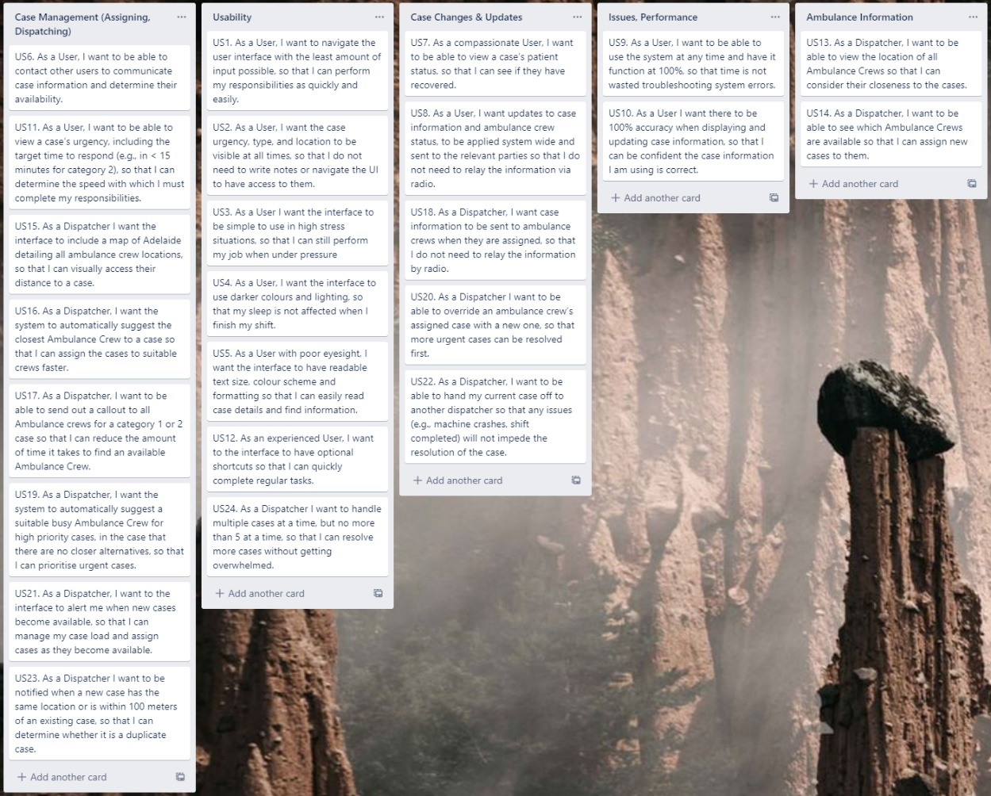

<https://trello.com/invite/b/za0QAOU4/dcad8cc9f2ef0623a88759da0d1a10ef/dispatcher-final-ia>

##### Response System

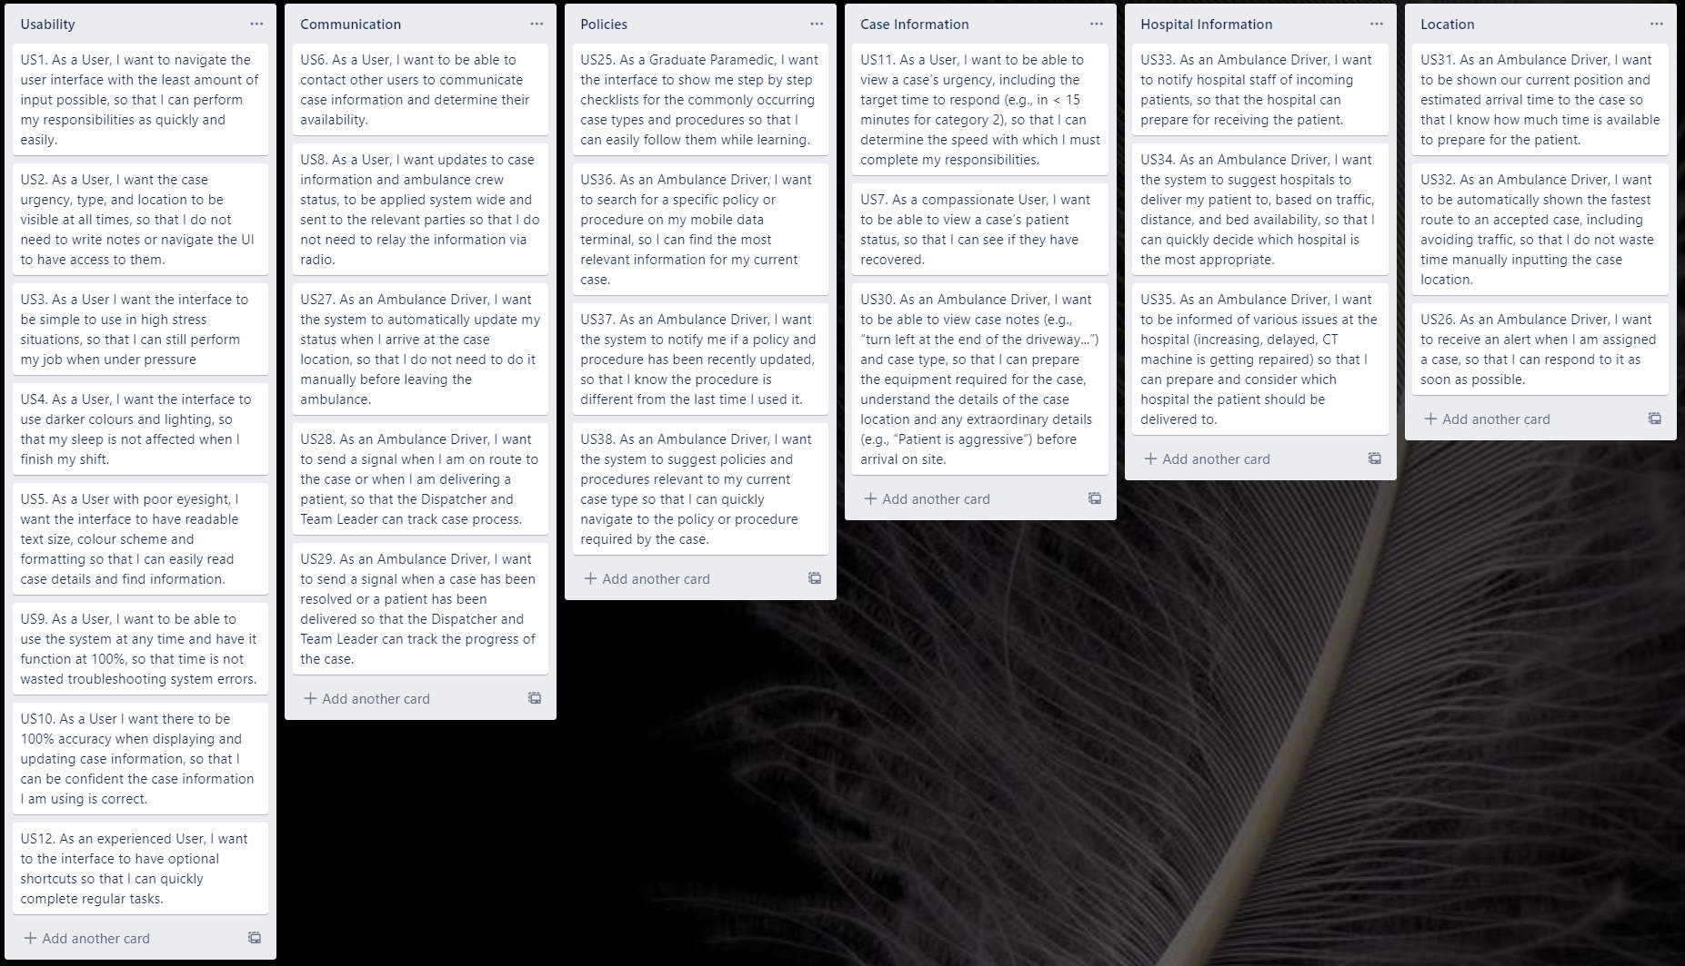

<https://trello.com/invite/b/1iZDmoF3/cc0cd4cb89a32cffeaf009d3caabe41c/response-final-ia>

### Navigational Scheme

The dispatch and response system will handle similar data. Both systems are complex enough to rule out using a navigational pattern like Nested Doll or Hub and Spoke. The user stories have revealed that users would like to see multiple parts of the system at all times (US2). With that requirement in mind, Tabbed view and the hierarchical pattern are also not viable.

The team has decided to use a combination of the dashboard pattern and the filtered view pattern for both subsystems. We believe that the user’s mental model would match nicely to a dashboard view. Many existing Emergency Management System’s use the dashboard pattern already and users are likely to be familiar with this layout. However, the subsystems are complex, they handle a diverse and deep data set. It would therefore be useful to use a filtered view nested in the dashboard for handling bulk data like cases and ambulances.

The below images use mobile tablets, but the patterns are also applicable to desktop devices.

|  |  |
| --- | --- |
|  |  |

## Look & Feel

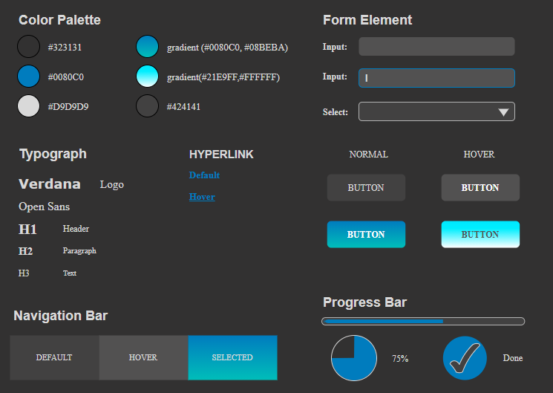

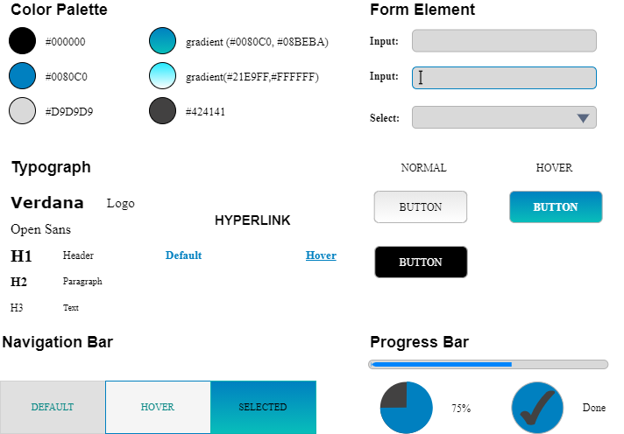

# Task 9 – Priority List of User Stories (AKA Backlog)

Given the number of user stories (24 for dispatch, 26 for response), techniques like the pairwise comparison will take an inordinate effort to complete (1,154 comparisons would need to be made by each team member).

The group therefore used a combination of the MoSCoW method and card sorting. Each member of the group sorted the user stories into the Must, Should, Could and Won’t categories for each subsystem, whilst pretending to be one of the relevant personas. An analysis of the results using ‘[Optimal Sort’](https://www.optimalworkshop.com/) revealed where user stories appeared the most and the percentage of appearance determined its rank of priority within the category.

Using an anonymous online tool had the disadvantage of not being able to discuss the reasoning for putting a card in a specific MoSCoW category. However, it also meant that no one member was able to influence the results of another member. This was an important advantage of the technique, given that the group did not have access to a real dispatcher or paramedic and were pretending to be the personas themselves.

## Dispatch System

### MoSCoW Results

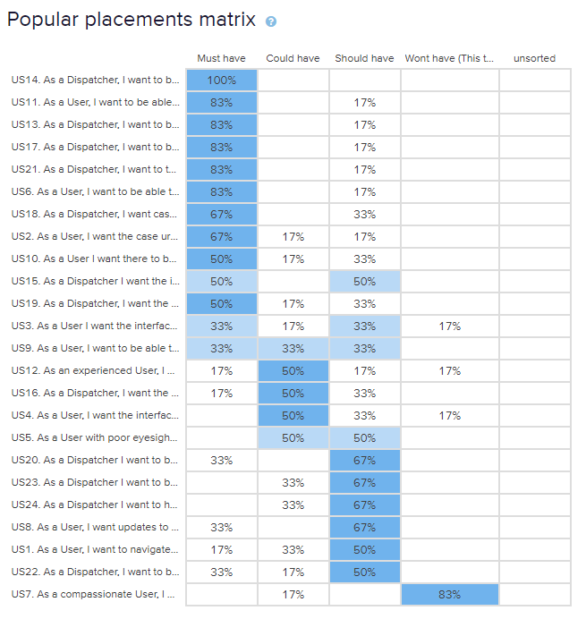

### Ordered list of stories

#### Must have

1. US14. As a Dispatcher, I want to be able to see which Ambulance Crews are available so that I can assign new cases to them.
2. US11. As a User, I want to be able to view a case’s urgency, including the target time to respond (e.g., in < 15 minutes for category 2), so that I can determine the speed with which I must complete my responsibilities.
3. US13. As a Dispatcher, I want to be able to view the location of all Ambulance Crews so that I can consider their closeness to the cases.
4. US17. As a Dispatcher, I want to be able to send out a callout to all Ambulance crews for a category 1 or 2 case so that I can reduce the amount of time it takes to find an available Ambulance Crew.
5. US21. As a Dispatcher, I want the interface to alert me when new cases become available, so that I can manage my case load and assign cases as they become available.
6. US6. As a User, I want to be able to contact other users, so that I can communicate case information and determine their availability.
7. US18. As a Dispatcher, I want case information to be sent to ambulance crews when they are assigned, so that I do not need to relay the information by radio.
8. US2. As a User, I want the case urgency, type, and location to be visible at all times, so that I do not need to write notes or navigate the UI to have access to them.
9. US10. As a User I want there to be 95% accuracy when displaying and updating case information, so that I can be confident the case information I am using is correct.
10. US19. As a Dispatcher, I want the system to automatically suggest a suitable busy Ambulance Crew for high priority cases, in the case that there are no closer alternatives, so that I can prioritise urgent cases.

#### Should have

1. US20. As a Dispatcher I want to be able to override an ambulance crew’s assigned case with a new one, so that more urgent cases can be resolved first.
2. US23. As a Dispatcher I want to be notified when a new case has the same location or is within 100 meters of an existing case, so that I can determine whether it is a duplicate case.
3. US24. As a Dispatcher I want to handle multiple cases at a time, but no more than 5 at a time, so that I can resolve more cases without getting overwhelmed.
4. US8. As a User, I want updates to case information and ambulance crew status, to be applied system wide and sent to the relevant parties so that I do not need to relay the information via radio.
5. US1. As a User, I want to navigate the user interface with the least amount of input possible, so that I can perform my responsibilities quickly and easily.
6. US22. As a Dispatcher, I want to be able to hand my current case off to another dispatcher so that any issues (e.g., machine crashes, shift completed) will not impede the resolution of the case.
7. US15. As a Dispatcher I want the interface to include a map of Adelaide detailing all ambulance crew locations, so that I can visually access their distance to a case.

#### Could have

1. US3. As a User I want the interface to be simple to use in high stress situations, so that I can still perform my job when under pressure
2. US9. As a User, I want to be able to use the system at any time and have it function at 95%, so that time is not wasted troubleshooting system errors.
3. US12. As an experienced User, I want the interface to have optional shortcuts so that I can quickly complete regular tasks.
4. US16. As a Dispatcher, I want the system to automatically suggest the closest Ambulance Crew to a case so that I can assign the cases to suitable crews faster.
5. US4. As a User, I want the interface to use darker colours and lighting, so that my sleep is not affected when I finish my shift.
6. US5. As a User with poor eyesight, I want the interface to have readable text size, colour scheme and formatting so that I can easily read case details and find information.

#### Won’t have (This time)

1. US7. As a compassionate User, I want to be able to view a case’s patient status, so that I can see if they have recovered.

## Response System

### MoSCoW Results

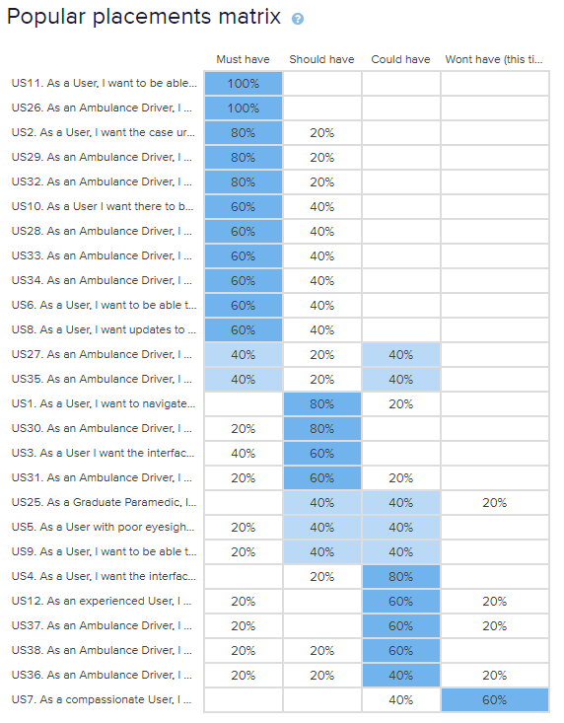

### Ordered list of stories

#### Must have

1. US26. As an Ambulance Driver, I want to receive an alert when I am assigned a case, so that I can respond to it as soon as possible
2. US11. As a User, I want to be able to view a case’s urgency, including the target time to respond (e.g., in < 15 minutes for category 2), so that I can determine the speed with which I must complete my responsibilities.
3. US2. As a User, I want the case urgency, type, and location to be visible at all times, so that I do not need to write notes or navigate the UI to have access to them.
4. US29. As an Ambulance Driver, I want to send a signal when a case has been resolved or a patient has been delivered so that the Dispatcher and Team Leader can track the progress of the case.
5. US32. As an Ambulance Driver, I want to be automatically shown the fastest route to an accepted case, including avoiding traffic, so that I do not waste time manually inputting the case location.
6. US10. As a User I want there to be 95% accuracy when displaying and updating case information, so that I can be confident the case information I am using is correct.
7. US38. As an Ambulance Driver, I want the system to suggest policies and procedures relevant to my current case type so that I can quickly navigate to the policy or procedure required by the case.
8. US33. As an Ambulance Driver, I want to notify hospital staff of incoming patients, so that the hospital can prepare for receiving the patient.
9. US34. As an Ambulance Driver, I want the system to suggest hospitals to deliver my patient to, based on traffic, distance, and bed availability, so that I can quickly decide which hospital is the most appropriate.
10. US6. As a User, I want to be able to contact other users, so that I can communicate case information and determine their availability.
11. US8. As a User, I want updates to case information and ambulance crew status, to be applied system wide and sent to the relevant parties so that I do not need to relay the information via radio.

#### Should have

1. US27. As an Ambulance Driver, I want the system to automatically update my status when I arrive at the case location, so that I do not need to do it manually before leaving the ambulance.
2. US35. As an Ambulance Driver, I want to be informed of various issues at the hospital (increasing, delayed, CT machine is getting repaired) so that I can prepare and consider which hospital the patient should be delivered to.
3. US1. As a User, I want to navigate the user interface with the least amount of input possible, so that I can perform my responsibilities quickly and easily.
4. US30. As an Ambulance Driver, I want to be able to view case notes (e.g., “turn left at the end of the driveway...”) and case type, so that I can prepare the equipment required for the case, understand the details of the case location and any extraordinary details (e.g., “Patient is aggressive”) before arrival on site.
5. US3. As a User I want the interface to be simple to use in high stress situations, so that I can still perform my job when under pressure
6. US31. As an Ambulance Driver, I want to be shown our current position and estimated arrival time to the case so that I know how much time is available to prepare for the patient.
7. US5. As a User with poor eyesight, I want the interface to have readable text size, colour scheme and formatting so that I can easily read case details and find information.
8. US9. As a User, I want to be able to use the system at any time and have it function at 95%, so that time is not wasted troubleshooting system errors.
9. US36. As an Ambulance Driver, I want to search for a specific policy or procedure on my mobile data terminal, so I can find the most relevant information for my current case.

#### Could have

1. US25. As a Graduate Paramedic, I want the interface to show me step by step checklists for the commonly occurring case types and procedures so that I can easily follow them while learning.
2. US12. As an experienced User, I want the interface to have optional shortcuts so that I can quickly complete regular tasks.
3. US37. As an Ambulance Driver, I want the system to notify me if a policy and procedure has been recently updated, so that I know the procedure is different from the last time I used it.
4. US38. As an Ambulance Driver, I want the system to suggest policies and procedures relevant to my current case type so that I can quickly navigate to the policy or procedure required by the case.

#### Won’t have (this time)

1. US7. As a compassionate User, I want to be able to view a case’s patient status, so that I can see if they have recovered.

# Task 10 – Prototype

## Dispatch:

### Assign Case (normal workflow – Related Storyboard: SB-3)

**Step 1: Login**

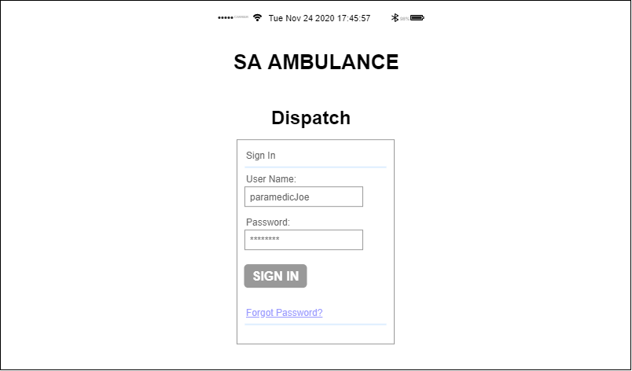

Login Page for Dispatcher: Type in username, password and click Sign In button.

**Step 2: View the Crew Map**

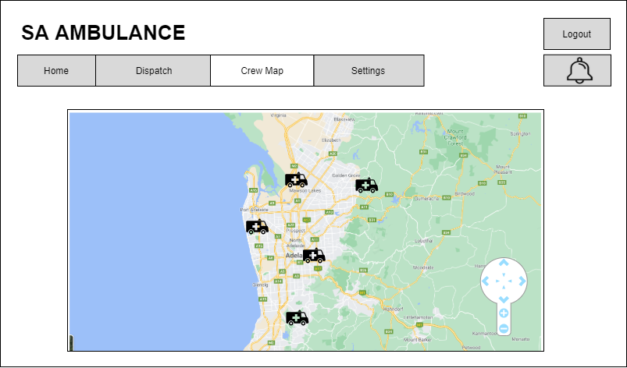

**Step 3: Receive new case**

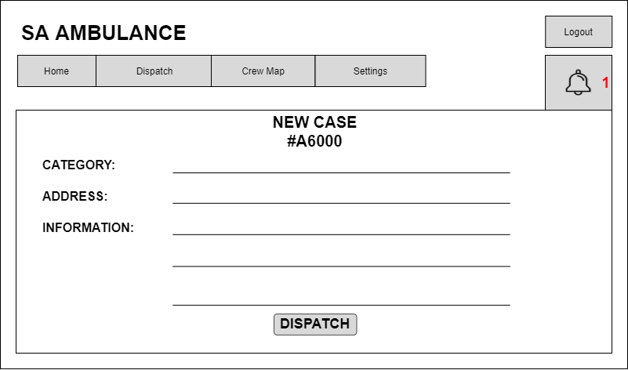

The notification of new case pops up on the screen with all provided information. Click Dispatch button to start the process.

**Step 4: Dispatch a case**

* First Method: Use system suggestion

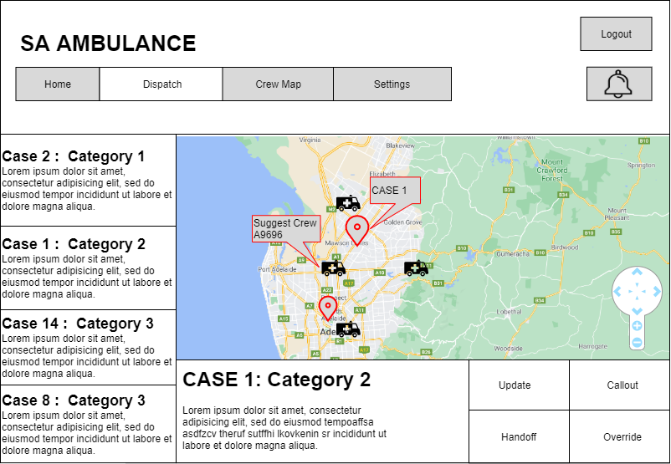

View the case location with all available Ambulance Crews on map. Click the suggestion to view.

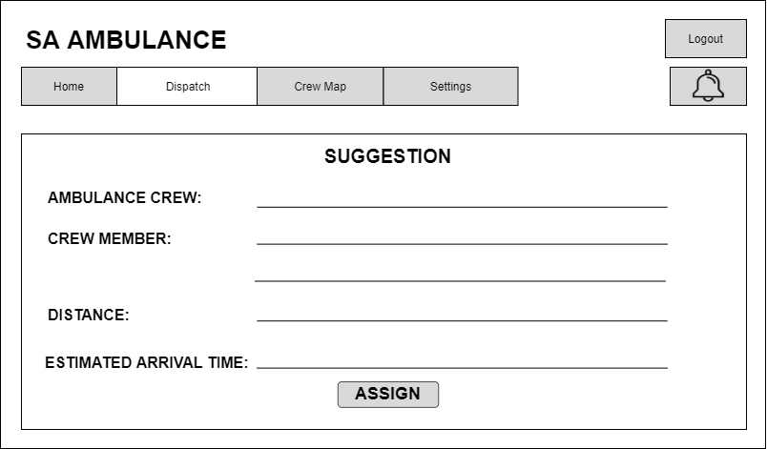

View the Crew suggestion and click Assign button to confirm.

* Second Method: Choose Ambulance Crew manually



Click on any Ambulance Crew icon to be assigned.

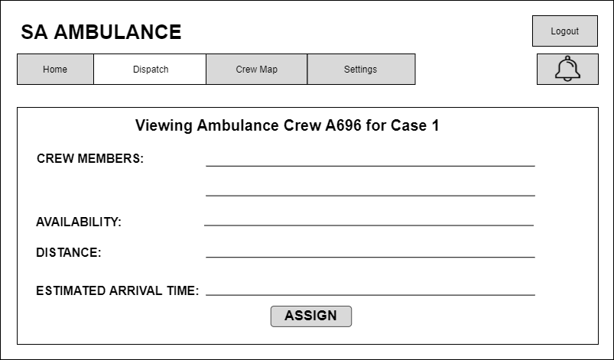

View the Crew information in terms of assigning to current case. Click Assign button to confirm.

**Step 5: View the Dispatch Confirmation**

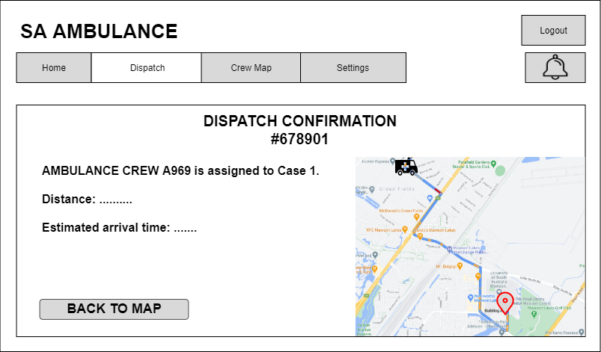

View the confirmation. Click Back to Map button to return to Crew Map page.

### Dispatch a higher priority case (no available Crew)

Related Storyboard: SB-5

Assuming Dispatcher has already done the first 3 steps of normal workflow Assign Case Prototype.

**Step 4: Dispatch new case**

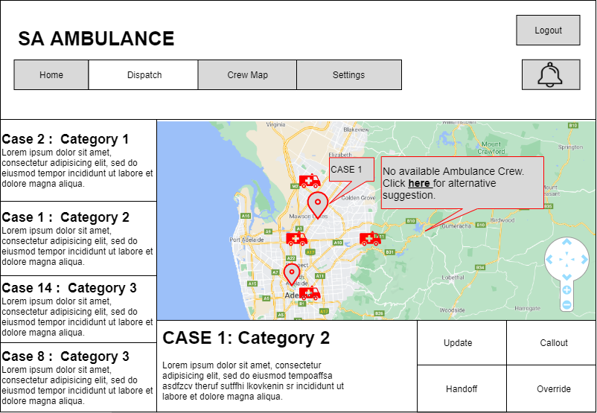

View the case location with all Ambulance Crew on the map. System warns that there are no available Ambulance Crew, then click that alert to view an alternative suggestion.

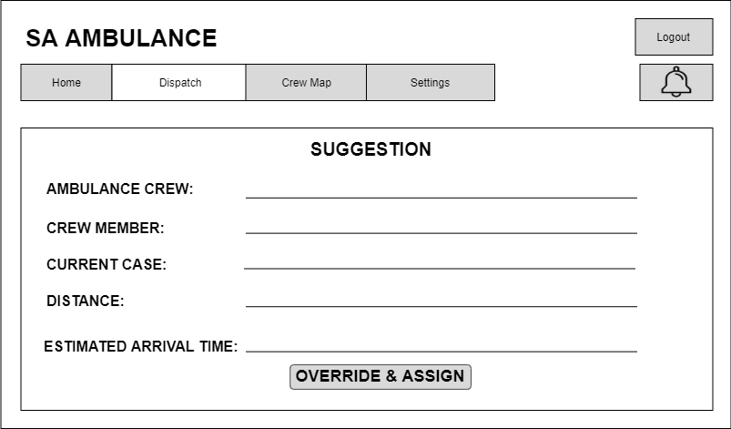

View the suggestion to consider if the new case has higher priority than the current case of suggested Crew. Click Override & Assign button to override the current case by the new one.

**Step 5: Override a case**

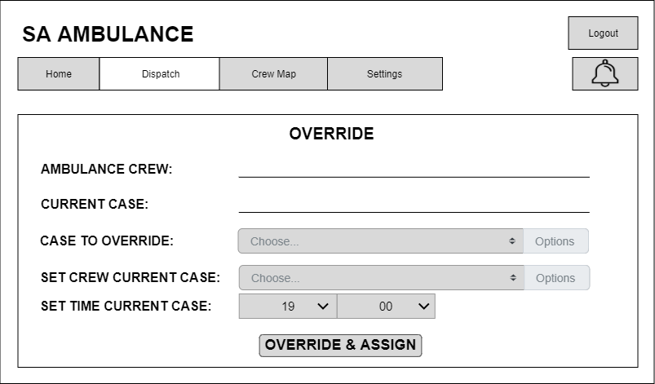

Choose the new case to override the current one, set the Crew to take current case instead or set time for this Ambulance Crew to do the current case after completing the override one. Click Override & Assign button to confirm.

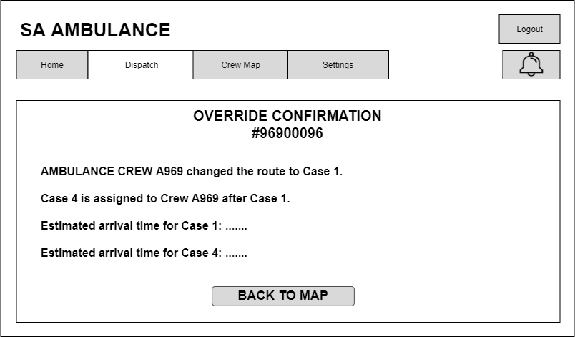

View the confirmation. Click Back to map button to return to Crew Map.

### Handoff a case



Choose Handoff button to forward case to another Dispatcher

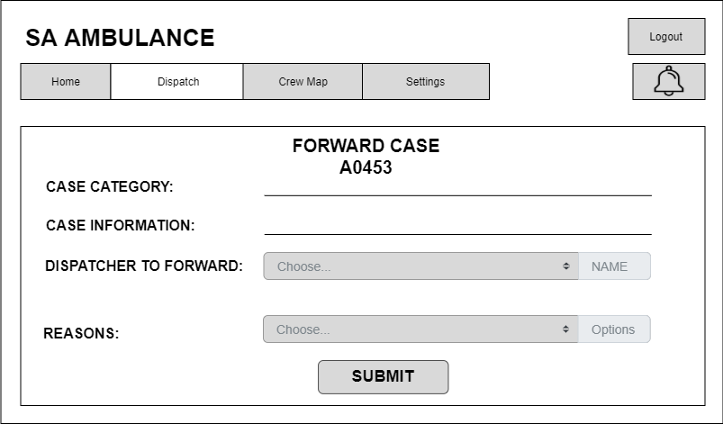

Choose the dispatcher to forward and reasons the Submit.

## Ambulance Driver:

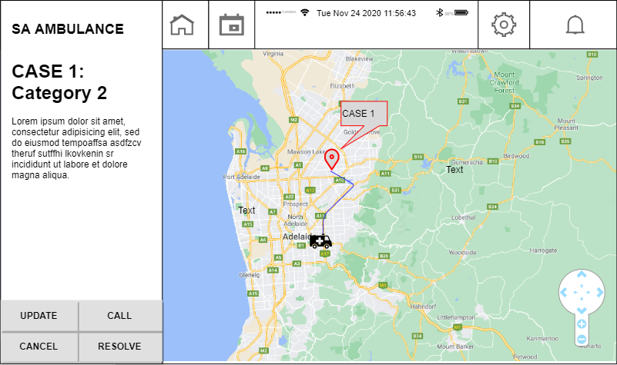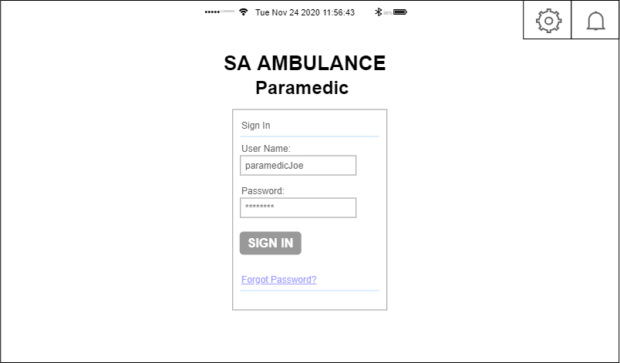Ambulance paramedic login page.

Home Page with ongoing case, and navigation.

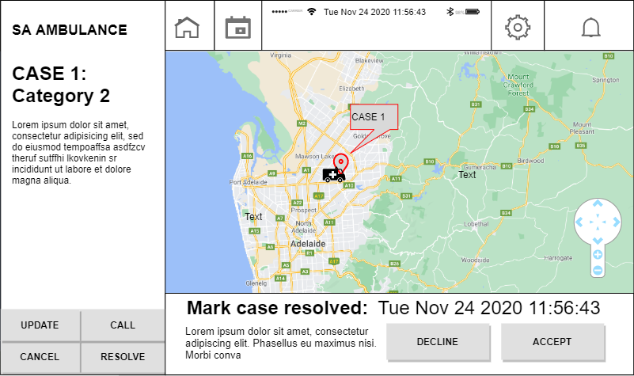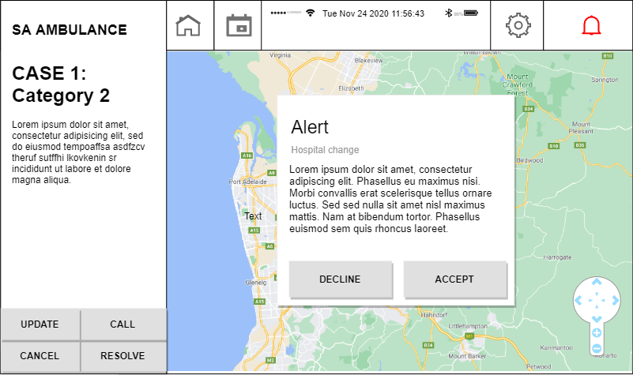Change in case alert, alert for a new case, change of drop off or anything else important.

Ongoing case, new options at bottom of page.

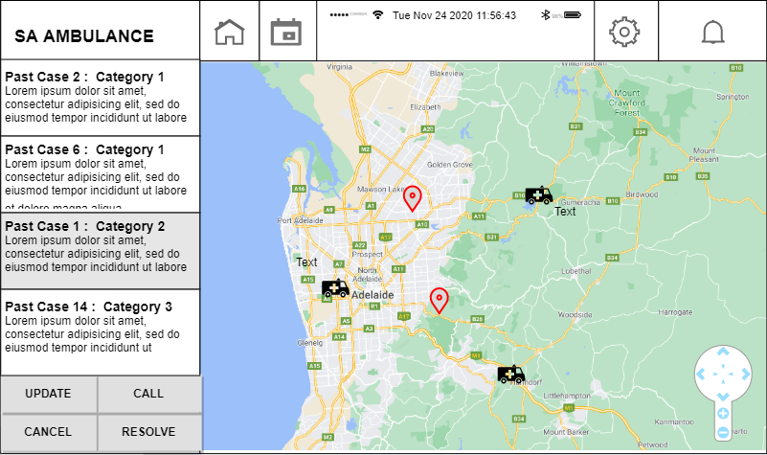

No case active, see and edit past cases, see other ambulances.

# Appendix 1 – Assumptions

1. The Ambulance Driver is a paramedic. Both Ambulance Drivers in an Ambulance Crew are paramedics, each one takes turns driving the ambulance.
2. Communication between users is achieved via a separate radio system. However, the frequencies required to contact other users are still needed inorder to achieve communication and the dispatch and response systems must provide that information somehow.

# Appendix 2 - Task Analysis

### Common to Both Systems

|  |  |  |
| --- | --- | --- |
| **User Activities (Low Level)** | **User Tasks (Medium Level)** | **User Stories (High Level)** |
| Communication | Contact other Users | 1. As a User, I want to be able to contact other users to communicate case information and determine their availability. |
| Update case information | 1. As a User, I want updates to case information and ambulance crew status, to be applied system wide and sent to the relevant parties so that I do not need to relay the information via radio. |
| View Case Information | View Patient information | 1. As a compassionate User, I want to be able to view a case’s patient status, so that I can see if they have recovered. |
| View case urgency | 1. As a User, I want to be able to view a case’s urgency, including the target time to respond (e.g., in < 15 minutes for category 2), so that I can determine the speed with which I must complete my responsibilities. |

### Dispatcher System

|  |  |  |
| --- | --- | --- |
| **User Activities (Low Level)** | **User Tasks (Medium Level)** | **User Stories (High Level)** |
| Communication | Ambulance Communication | US17. As a Dispatcher, I want to be able to send out a callout to all Ambulance crews for a category 1 or 2 case so that I can reduce the amount of time it takes to find an available Ambulance Crew. |
| Case Management | Assigning a case | US18. As a Dispatcher, I want case information to be sent to ambulance crews when they are assigned, so that I do not need to relay the information by radio.  US24. As a Dispatcher I want to handle multiple cases at a time, but no more than 5 at a time, so that I can resolve more cases without getting overwhelmed. |
| Case Notifications | US21. As a Dispatcher, I want the interface to alert me when new cases become available, so that I can manage my case load and assign cases as they become available.  US23. As a Dispatcher I want to be notified when a new case has the same location or is within 100 meters of an existing case, so that I can determine whether it is a duplicate case. |
| Case Management | US20. As a Dispatcher I want to be able to override an ambulance crew’s assigned case with a new one, so that more urgent cases can be resolved first.  US22. As a Dispatcher, I want to be able to hand my current case off to another dispatcher so that any issues (e.g., machine crashes, shift completed) will not impede the resolution of the case. |
| Ambulance Management | Choosing an ambulance help | US16. As a Dispatcher, I want the system to automatically suggest the closest Ambulance Crew to a case so that I can assign the cases to suitable crews faster.  US19. As a Dispatcher, I want the system to automatically suggest a suitable busy Ambulance Crew for high priority cases, in the case that there are no closer alternatives, so that I can prioritise urgent cases. |
| Viewing Ambulance Location and availability | US13. As a Dispatcher, I want to be able to view the location of all Ambulance Crews so that I can consider their closeness to the cases.  US14. As a Dispatcher, I want to be able to see which Ambulance Crews are available so that I can assign new cases to them.  US15. As a Dispatcher I want the interface to include a map of Adelaide detailing all ambulance crew locations, so that I can visually access their distance to a case. |

### Ambulance System

|  |  |  |
| --- | --- | --- |
| **User Activities (Low Level)** | **User Tasks (Medium Level)** | **User Stories (High Level)** |
| Communication | Case notifications | US26. As an Ambulance Driver, I want to receive an alert when I am assigned a case, so that I can respond to it as soon as possible. |
| Signalling status | US27. As an Ambulance Driver, I want the system to automatically update my status when I arrive at the case location, so that I do not need to do it manually before leaving the ambulance.  US28. As an Ambulance Driver, I want to send a signal when I am on route to the case or when I am delivering a patient, so that the Dispatcher and Team Leader can track case process.  US29. As an Ambulance Driver, I want to send a signal when a case has been resolved or a patient has been delivered so that the Dispatcher and Team Leader can track the progress of the case. |
| Hospital Communication | US33. As an Ambulance Driver, I want to notify hospital staff of incoming patients, so that the hospital can prepare for receiving the patient. |
| Managing Case | Viewing case information | US30. As an Ambulance Driver, I want to be able to view case notes (e.g., “turn left at the end of the driveway...”) and case type, so that I can prepare the equipment required for the case, understand the details of the case location and any extraordinary details (e.g., “Patient is aggressive”) before arrival on site. |
| Location and time management | US31. As an Ambulance Driver, I want to be shown our current position and estimated arrival time to the case so that I know how much time is available to prepare for the patient.  US32. As an Ambulance Driver, I want to be automatically shown the fastest route to an accepted case, including avoiding traffic, so that I do not waste time manually inputting the case location. |
| Choose delivery hospital | US34. As an Ambulance Driver, I want the system to suggest hospitals to deliver my patient to, based on traffic, distance, and bed availability, so that I can quickly decide which hospital is the most appropriate.  US35. As an Ambulance Driver, I want to be informed of various issues at the hospital (increasing, delayed, CT machine is getting repaired) so that I can prepare and consider which hospital the patient should be delivered to. |
| Procedures and Policies | Selecting a Procedure or Policy | US36. As an Ambulance Driver, I want to search for a specific policy or procedure on my mobile data terminal, so I can find the most relevant information for my current case.  US37. As an Ambulance Driver, I want the system to notify me if a policy and procedure has been recently updated, so that I know the procedure is different from the last time I used it.  US38. As an Ambulance Driver, I want the system to suggest policies and procedures relevant to my current case type so that I can quickly navigate to the policy or procedure required by the case. |
| Using a procedure or policy | US25. As a Graduate Paramedic, I want the interface to show me step by step checklists for the commonly occurring case types and procedures so that I can easily follow them while learning. |

# Appendix 3 - Card Sorting – Information Architecture

**Dispatch System**

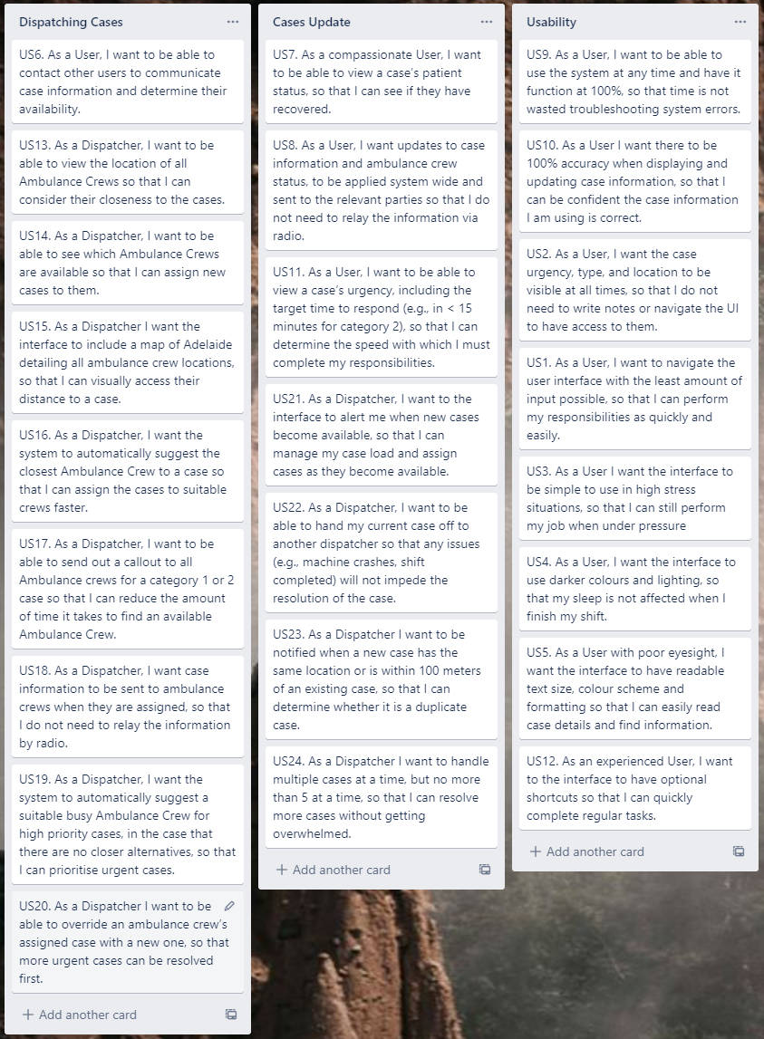

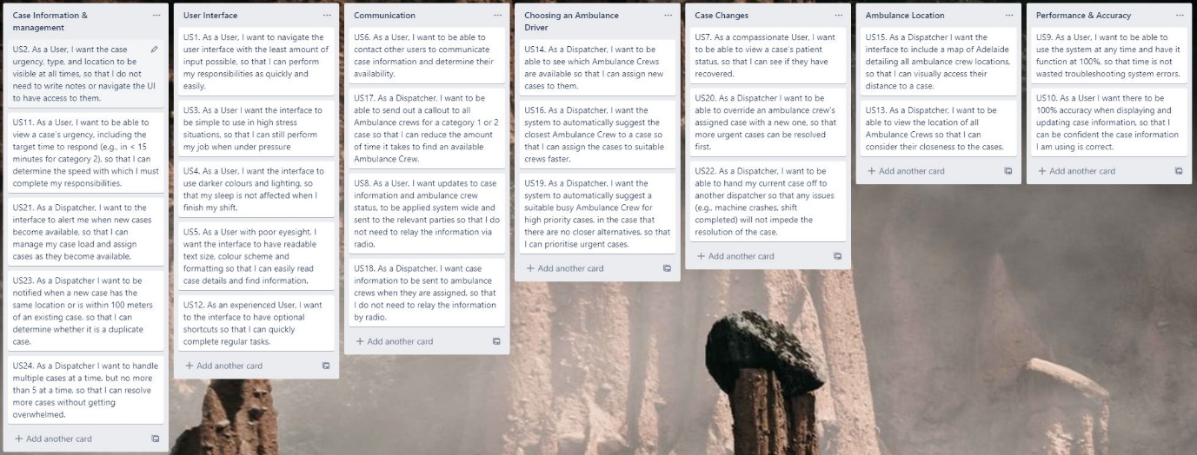

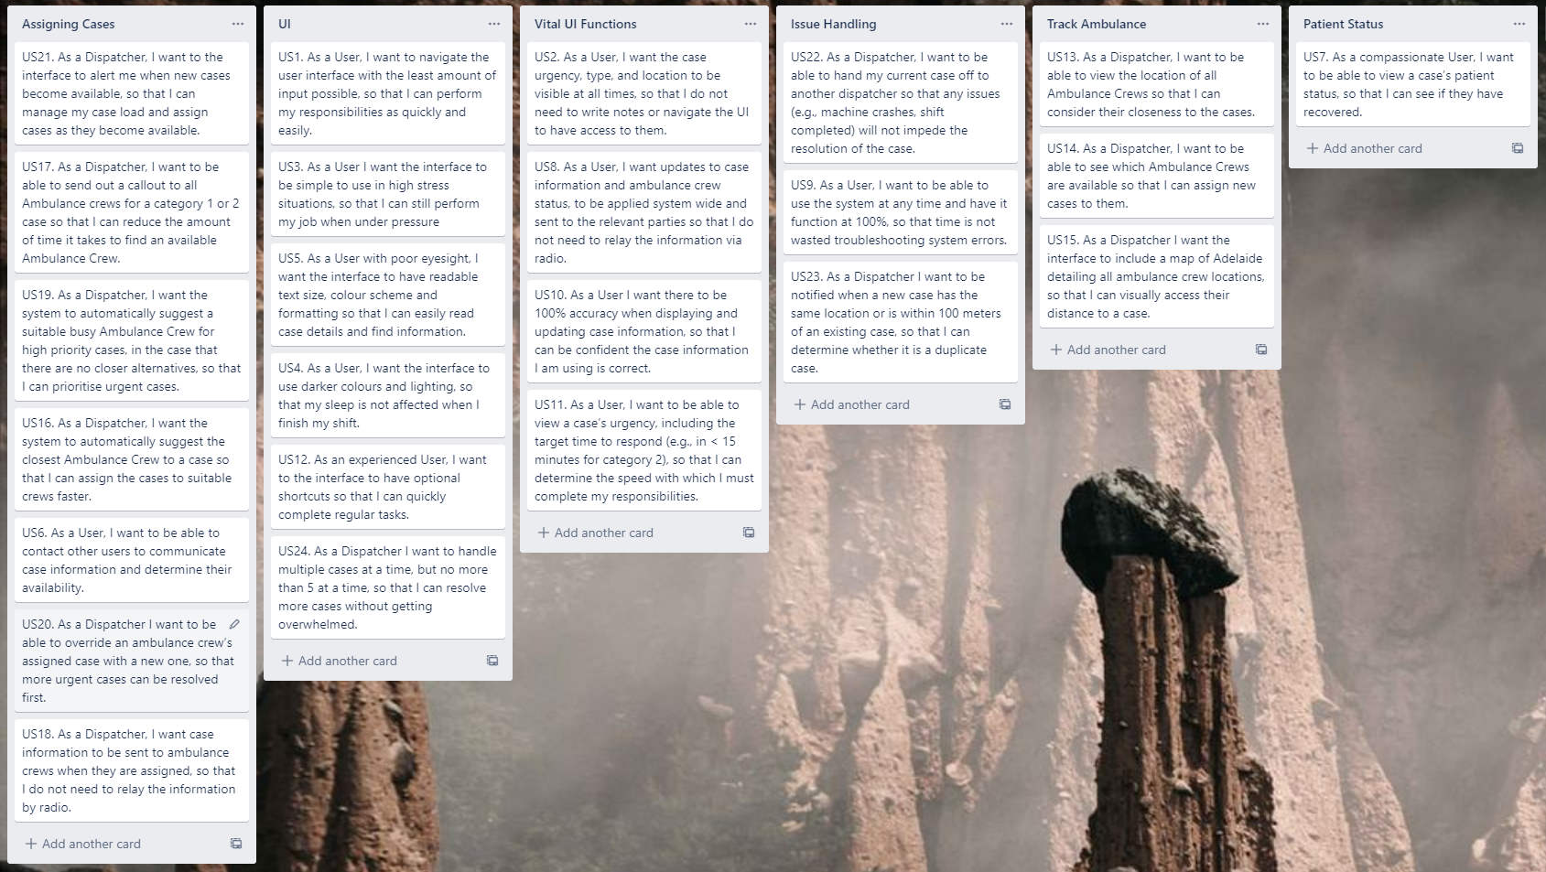

**Response System**

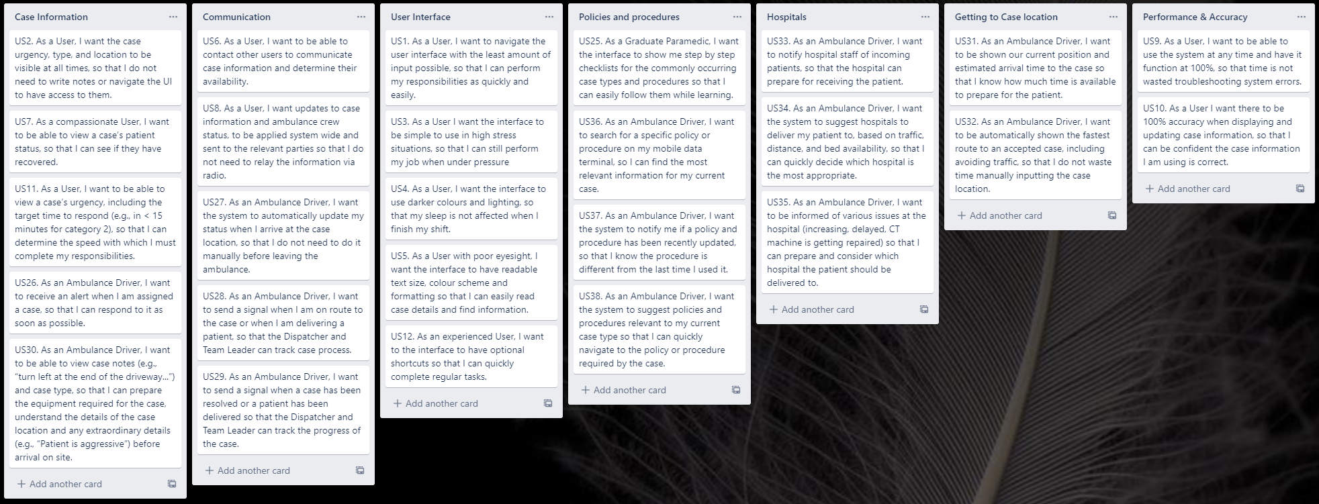

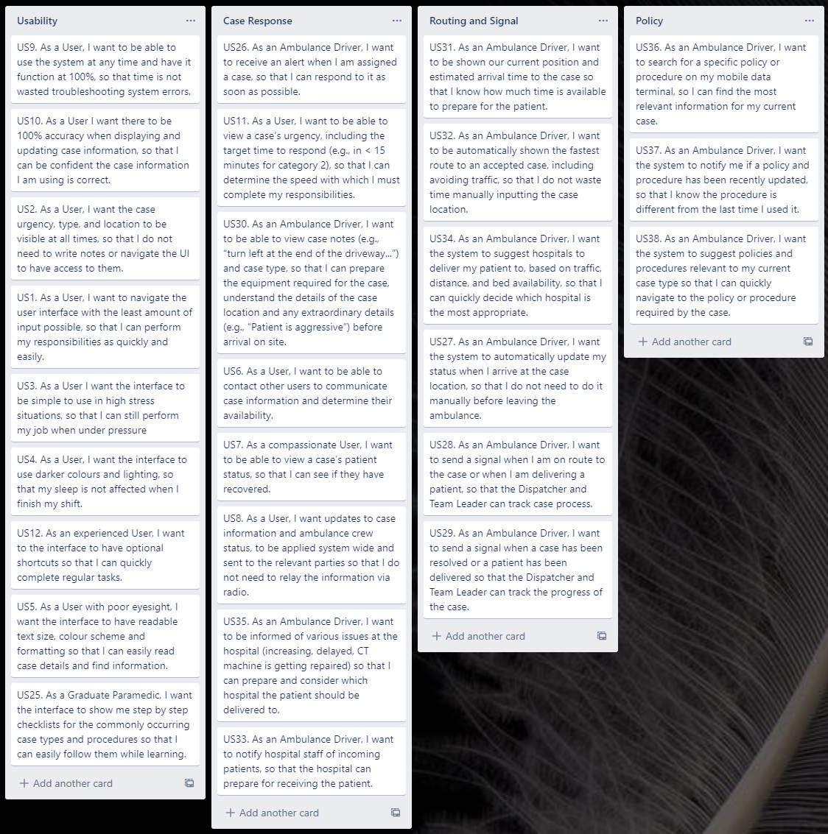

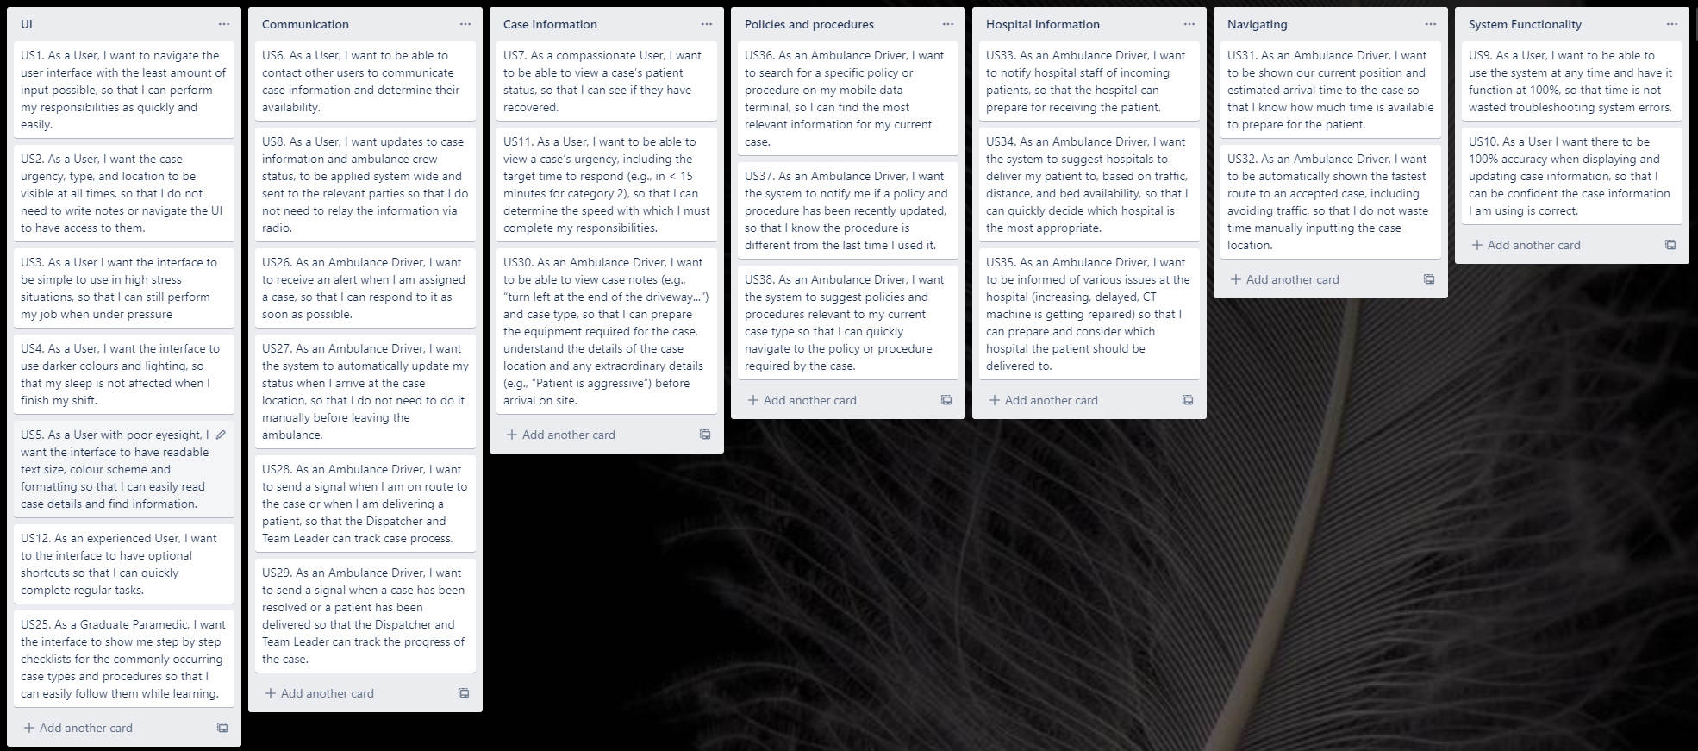

# Appendix 4 – References

1. SA Amublance Service, 2020. *Vision, Mission and Values | SAAS, viewed 3 November 2020*

<http://www.saambulance.com.au/Whoweare/Visionmissionandvalues.aspx>

1. SA Amublance Service, 2020. *Freedom of Information | SAAS, viewed 3 November 2020*

<http://www.saambulance.com.au/ContactUs/FreedomofInformation.aspx>

1. SA Ambulance Service, 2020. *SA Ambulance Service > Who we are > Structure, viewed 3 November 2020*

<http://www.saambulance.com.au/Whoweare/Structure.aspx>

1. SA Health, 2020. About SA Health | SA Health*, viewed 3 November 2020*

<https://www.sahealth.sa.gov.au/wps/wcm/connect/public+content/sa+health+internet/about+us/about+sa+health/about+sa+health>

1. SA Health, 2020. Ambulance Service Dashboard | SA Health*, viewed 3 November 2020*

<https://www.sahealth.sa.gov.au/wps/wcm/connect/public+content/sa+health+internet/about+us/our+performance/our+hospital+dashboards/about+the+ambulance+service+dashboard/ambulance+service+dashboard>

1. SAMFS, 2020. Our Organisation - SAMFS*, viewed 3 November 2020*

<https://www.mfs.sa.gov.au/about-us/our-organisation/>

1. SAPOL, 2020. SAPOL – Who we are*, viewed 3 November 2020*

<https://www.police.sa.gov.au/about-us/who-we-are>

1. Mader International Pty. Ltd, 2020. Company – Mader International*, viewed 5 November 2020*

<https://mader.com.au/company>

1. AEASA, 2020. About Us – Ambulance Employees Association*, viewed 3 November 2020*

<https://www.aeasa.com.au/about-us/>

1. SA Ambulance Service, 2020. *Consumer and Community Engagement, viewed 3 November 2020*

<http://www.saambulance.com.au/Whoweare/ConsumerandCommunityEngagement.aspx>

1. Paramedicine Board of Australia, 2020. *Registration Standards | Ahpra, viewed 12 November 2020*

<https://www.paramedicineboard.gov.au/Professional-standards/Registration-standards.aspx>

1. SAAS Ministerials - SAAS Annual Report 2018_2019 - ANNUAL REPORT 18_19, Page 12, *viewed 18 November 2020*

<http://www.saambulance.com.au/LinkClick.aspx?fileticket=GZhLa_-nft0%3D&tabid=122>

**Additional References**

NOTE: The following references were used in for background research in to the system but they are not directly quoited or sited in the report and therfore do not have footnote annotations.

**SAAS Background**

SA Ambulance Service, 2020. *National Accreditation, viewed 3 November 2020*

<http://www.saambulance.com.au/NewsPublications/NSQHSStandards.aspx>

SA Ambulance Service, 2020. *SA Ambulance Service > Who we are > Facts and Figures, viewed 3 November 2020*

<http://www.saambulance.com.au/Whoweare/Factsandfigures.aspx>

SA Ambulance Service, 2020. *SA Ambulance Service > Who we are > Vehicles, viewed 3 November 2020*

<http://www.saambulance.com.au/Whoweare/Vehicles.aspx>

SA Ambulance Service, 2020. *Training and Education | SAAS, viewed 3 November 2020*

<http://www.saambulance.com.au/Volunteering/Trainingandeducation.aspx>

**User Interface Design**

Apple Human Interface Guidelines, 2020. Providing User Feedback - User Interaction - macOS, *viewed 20 November2020*

<https://developer.apple.com/design/human-interface-guidelines/macos/user-interaction/providing-user-feedback/>

Google Material Design, 2020. Confirmation & Acknowledgement - Material Design, v*iewed* *20 November 2020*

<https://material.io/design/communication/confirmation-acknowledgement.html#usage>

Google Material Design, 2020. Text Fields - Material Design, *viewed 20 November 2020*

<https://material.io/components/text-fields#anatomy>

Nielsen, J., 1993. Response Times: The 3 Important Limits. In: *Usability Engineering.* s.l.:Academic Press. Page 1, *viewed 20 November 2020*

<https://immagic.com/eLibrary/ARCHIVES/GENERAL/NNG_US/N930101N.pdf>